**جامعة المستقبل \العراق-بابل**

**كلية الهندسة والتقنيات الهندسية \قسم تقنيات الهندسة الكهربائية**

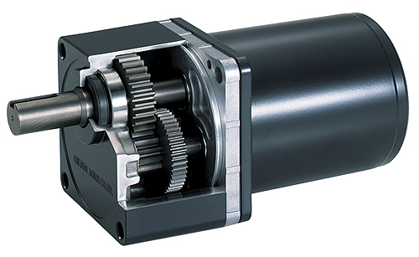

**Lecture -2**

**By**

**Dr. JABER ALQADHI**

**Reverse direction of rotation – back e.m.f. equivalent**

**Back E.M.F. and Voltage Equation of D.C. Motor**

**When the armature of a d.c. motor rotates under the influence of the driving torque, the armature conductors move through the magnetic field and hence e.m.f. is induced in them as in a generator. The induced e.m.f. acts in opposite direction to the applied voltage V (Lenz’s law) and in known as back or counter e.m.f. (Eb). The back EMF is always less than V, although this difference is small when the motor is running under normal conditions.**

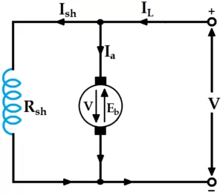

**Fig. 1**

|  |  |  |  |
| --- | --- | --- | --- |
|  |  |  | **(1)** |

**Consider the shunt wound motor shown in the figure above. When DC voltage V is applied across the motor terminals, the field magnets are excited and current is supplied to the armature conductors. Hence, the driving torque acts on the armature which starts rotating.**

**As the armature rotates, a back emf Eb is induced which opposes the applied voltage V. The applied voltage V is to force the current through the armature against the back emf Eb.**

**The electric work done in overcoming and causing the current to flow against Eb is converted into mechanical energy developed in the armature. Therefore, it follows that energy conversion in a DC motor is possible only due to the production of back emf Eb.**

**Net voltage in armature circuit = V – Eb**

**If Ra is the armature circuit resistance, then,**

|  |  |  |  |
| --- | --- | --- | --- |
|  |  |  | **(2)** |

|  |  |  |  |
| --- | --- | --- | --- |
| ***V*** |  | **+** | **(3)** |

**This is known as voltage equation of the D.C. motor. Now, multiplying both sides by , we get:**

|  |  |  |  |
| --- | --- | --- | --- |
|  |  | **+** | **(4)** |

**= Eectrical input to the armature**

**= Electrical equivalent of mechanical power developed in the armature**

**= Cu loss in the armature**

**Condition for Maximum Power**

**The gross mechanical power developed by a motor is**

|  |  |  |  |
| --- | --- | --- | --- |
|  |  | **.** | **(5)** |

**Differentiating both sides with respect to and equating the result to zero, we get**

|  |  |
| --- | --- |
|  | **(6)** |

**Thus, gross mechanical power developed by a motor is maximum when back e.m.f. is equal to half the applied voltage. This condition is, however, not realized in practice, because in that case current would be much beyond the normal current of the motor. Moreover, half the input would be wasted in the form of heat and taking other losses (mechanical and magnetic) into consideration, the motor efficiency will be well below 50 percent.**

**Example 1: A 440-V, shunt motor has armature resistance of 0.8 Ω and field resistance of 200 Ω. Determine the back e.m.f. when giving an output of 7.46 kW at 85 % efficiency.**

**Solution**

**Motor input power = 7.46 × 103/0.85 = 8776 W**

**Motor input current = 8776 / 440 = 19.95 A**

**Ish = 440/200 = 2.2 A**

**= 19.95 − 2.2 = 17.75 A**

**= V − 440 − (17.75 × 0.8) = 425.8 V**

**Example 2: A 4 pole, 32 conductor, lap-wound d.c. shunt generator with terminal voltage of 200 volts delivering 12 amps to the load has = 2 Ω and field circuit resistance of 200 Ω. It is driven at 1000 r.p.m. Calculate the flux per pole in the machine. If the machine has to be run as a motor with the same terminal voltage and drawing 5 A from the mains, maintaining the same magnetic field, find the speed of the machine.**

**Solution**

**As a generator,**

**= 13 A**

**Eg = 200 + (13 × 2) = 226 V**

**As a motor,**

**= 13A**

**Torque**

**By the term torque is meant the turning or twisting moment of a force about an axis. It is measured by the product of the force and the radius at which this force acts. Consider a pulley of radius r metre acted upon by a circumferential force of F Newton which causes it to rotate at N r.p.m.**

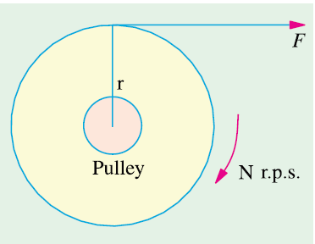

**Fig. 2**

**Then torque**

|  |  |  |  |
| --- | --- | --- | --- |
| **T** |  |  | **Newton-metre (7)** |

**Work done by this force in one revolution = Force × distance = F × 2πr Joule**

|  |  |  |  |
| --- | --- | --- | --- |
| **Power developed** |  |  | **Joule/second or Watt (8)** |

**or**

|  |  |  |  |
| --- | --- | --- | --- |
| **Power developed** |  |  | **Joule/second or Watt (9)** |

**Armature Torque of a Motor**

**Let be the torque developed by the armature of a motor running at r.p.m. The power developed = watt**

**We also know that electrical power converted into mechanical power in the armature = then**

**But then we have,**

|  |  |  |  |
| --- | --- | --- | --- |
|  |  |  | **N-m (10)** |

**Or**

|  |  |  |  |
| --- | --- | --- | --- |
|  |  |  | **N-m (11)** |

**Shaft Torque (Tsh)**

**The whole of the armature torque, as calculated above, is not available for doing useful work, because a certain percentage of it is required for supplying iron and friction losses in the motor. The torque which is available for doing useful work is known as shaft torque Tsh. It is so called because it is available at the shaft. The motor output is given by:**

|  |  |  |  |
| --- | --- | --- | --- |
| **Output** |  |  | **Watt (12)** |

**Provided Tsh is in N-m and N in r.p.m.**

|  |  |  |  |
| --- | --- | --- | --- |
|  |  |  | **N-m (13)** |

**The difference (Ta − Tsh) is known as lost torque and is due to iron and friction losses of the motor.**

**Example 3: Determine developed torque and shaft torque of 220-V, 4-pole series motor with 800 conductors’ wave-connected supplying a load of 8.2 kW by taking 45 A from the mains. The flux per pole is 25 mWb and its armature circuit resistance is 0.6 Ω.**

**Solution**

**Developed torque or gross torque is the same thing as armature torque.**

**Example 4: A 4-pole, 240 V, wave connected shunt motor gives 11.19 kW when running at 1000 r.p.m. and drawing armature and field currents of 50 A and 1.0 A respectively. It has 540 conductors. Its resistance is 0.1 Ω. Assuming a drop of 1 volt per brush, find (a) total torque (b) useful torque (c) useful flux / pole (d) Armature input , losses and rotational losses (e) efficiency.**

**Solution**

1. **Armature input =**

**Armature Cu loss = = 502 × 0.1 = 250 W**

**Brush contact loss = 50 × 2 = 100 W**

**Power developed =**

**Output = 11190 W**

**Rotational losses =**

1. **motor input = VI = 240 × 51=12340 W**

**Speed of a D.C. Motor**

**From the voltage equation of a motor, we get:**

|  |  |  |  |
| --- | --- | --- | --- |
|  |  |  | **(14)** |

|  |  |  |  |
| --- | --- | --- | --- |
|  |  |  | **(15)** |

|  |  |  |  |
| --- | --- | --- | --- |
|  |  |  | **(16)** |

**Or**

|  |  |  |  |
| --- | --- | --- | --- |
|  |  |  | **(17)** |

**It shows that speed is directly proportional to back e.m.f.**

**For Series Motor**

**N1 = Speed in the 1st case**

**Ia1 = armature current in the 1st case**

**1 = flux/pole in the first case**

**N2, Ia2, 2 = corresponding quantities in the 2nd case.**

**Then, using the above relation, we get**

**Then**

|  |  |  |  |
| --- | --- | --- | --- |
|  |  |  | **(18)** |

**Prior to saturation of magnetic poles, then**

|  |  |  |  |
| --- | --- | --- | --- |
|  |  |  | **(19)** |

**For Shunt Motor**

**In this case the same equation applies as in Eq 18.**

**If then**

|  |  |  |  |
| --- | --- | --- | --- |
|  |  |  | **(20)** |

**Example 5: A d.c. series motor operates at 800 r.p.m. with a line current of 100 A from 230-V mains. Its armature circuit resistance is 0.15 Ω and its field resistance 0.1 Ω. Find the speed at which the motor runs at a line current of 25 A, assuming that the flux at this current is 45 per cent of the flux at 100 A.**

**Solution**