**جامعة المستقبل \العراق-بابل**

**كلية الهندسة والتقنيات الهندسية \قسم تقنيات الهندسة الكهربائية**

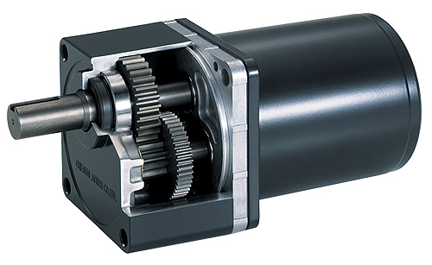

**Lecture -1-**

**By**

**Dr. JABER ALQADHI**

**DC motor, principle of dc motors torque develops in motor.**

**D.C. motors**

**The construction of a d.c. motor is the same as a d.c. generator. The only difference**

**is that in a generator the generated e.m.f. is greater than the terminal voltage,**

**where as in a motor the generated e.m.f. is less than the terminal voltage.**

**D.C. motors are often used in power stations to drive emergency stand-by pump**

**systems which come into operation to protect essential equipment and plant**

**should the normal a.c. supplies or pumps fail.**

**DC motor is a machine that converts electrical energy of direct current into mechanical energy. In a DC motor, the input electrical energy is direct current which is converted into mechanical rotation.**

**There are many applications for DC motors, they can be used in robotics; electric vehicles, and some industrial machinery as well as household devices. DC motor can be used at such places where speed control is required. That is why DC motors are often used in trolleys, electric train production systems, elevators, etc.**

**DC Motor Definition**

**DC motor, also known as a direct current motor, is an electric motor that converts mechanical energy from the electrical energy of direct current.**

**DC Motor Diagram**

**Diagram of Direct Current Motor is shown below:**

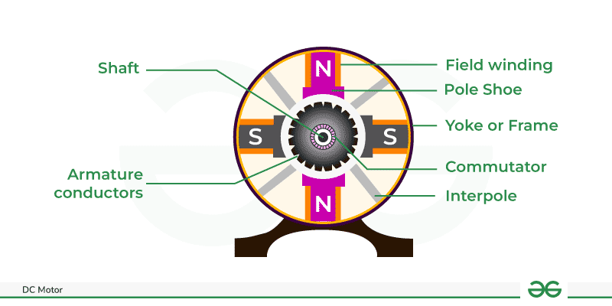

**Construction of DC Motor**

**DC motor has such basic components, as a stator (stationary part of the element producing magnetic field) and a rotor part that rotates carrying winding or coil. When a DC voltage is connected to the coil, current flows through it and generates an electromagnetic field. When the magnetic field of this rotor interacts with that produced by the stator, a torque is induced which causes this piece to start spinning.**

**DC Motor Parts**

**DC machine has the following main parts:**

**1-Field System or Stator**

**2-Armature**

**3-Commutator**

**4Brushes**

**Field Coil or Stator**

**As the name suggests, the field coil or stator is the non moving or the stationary part of the DC motor around which coil is wounded and produce magnetic field**

**The stator consists of various parts:**

**Yoke**

**Pole Core**

**Pole Body**

**Shoe for the pole**

**Field Winding**

**End Plates**

**Yoke: The structure of a DC machine works to create the magnetic circuit between the poles.**

**Pole Core: Pole Core is usually of laminated iron or other magnetic material. Its function is to serve as a passage for the magnetic flux generated by the field winding.**

**Pole Body: Pole body works with the pole core. When an electric current passes through the field winding, a magnetic flux is established not only in the pole core but also around it. The poles and their bearings are known as the pole bod**

**Shoe: Shoe is a synonym for one of the brushes inside an electric motor. DC motors have brushes to make contact with the rotating armature, and typically they are sodded.**

**Field Winding: Field winding is on the pole core next to the stator. Field winding uses insulated copper wire. An insulated copper coil is wound**

**round the pole core. If this coil on the pole core is excited with direct current, we get magnetic flux.**

**End Plates: End plates encapsulate the entire motor. They provide a casing for all of the internal parts--the armature, commutator and brushes as well sometimes also including field windings**

**Armature**

**Armature is the rotating part of the motor which generates mechanical energy. Armature core has windings. The armature core is made of 0.3 to 0.5 mm thick high magnetic strength (silicon steel lamination) and a thin layer of varnish is applied on each she**

**Commutator**

**Commutators are used in DC appliances such as DC Motors and DC Generators. It periodically reverses the current between the armature and the circuit and produces steady torque**

**Brushes**

**Brushes or often called Carbon Brushes are made up of graphite. In DC Motors, brushes supplies current to the winding of the armature.**

**DC Motor Working Principle**

**When a current carrying conductor is placed in a magnetic field, a mechanical force acts on it, which can be determined by Fleming's left hand rule. Due to this force the conductor becomes mobile in the direction of the force.**

**Working-Principle-of-DC-Motor**

**DC Motor Working**

**Imagine that a current-free conductor (which is not connected to the supply) is placed in the main magnetic field the and without the magnetic field flowing through the conductor. Assume, there is an air gap from N pole to S pole.**

**Current is flowing in the conductor but the magnetic effect of N pole and S pole has been removed. In this situation the conductor will maintain its own magnetic field. The magnetic field lines of force of the conductor will be clockwise according to the cork screw rule.**

**Current is flowing in the conductor and main magnetic field is also present. The magnetic field produced due to the current in the conductor acts along with the main field above the conductor but opposes the main field below the conductor. The result is that flux accumulates in the region above the conductor and flux density reduces in the region below.**

**From this it is clear that when the force is acting on the conductor, it works to push the conductor downwards. If the direction of current in the conductor is changed, the flux will accumulate downwards and will try to move the conductor upwards**