**Thevenin and Norton Equivalent Circuits**

Thevenin's and Norton's theorems are applied to ac circuits in the same way as they are to de circuits.

The only additional effort arises from the need to manipulate complex numbers. The frequency-domain version of a Thevenin and Norton equivalent circuits is depicted in the figure below:

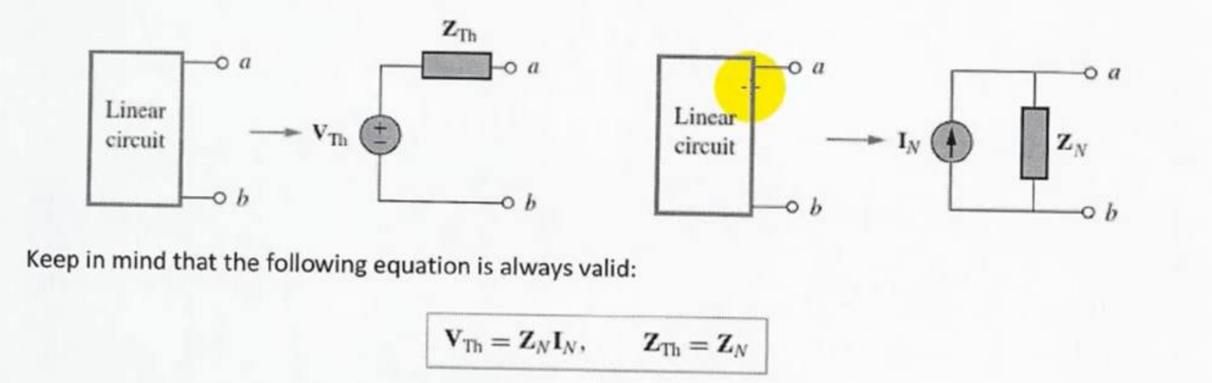

EXAMPLE : obtain the thevenin equivalent terminal **a** and **b**  of the following circuit

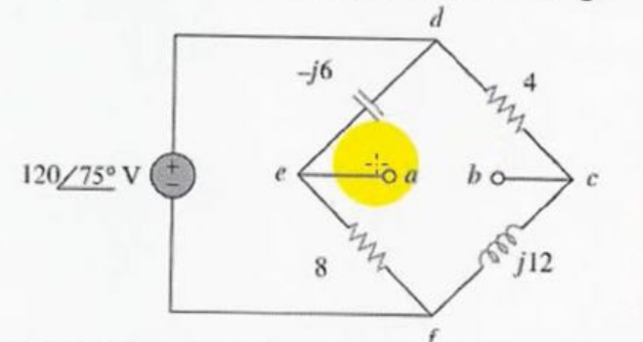

Solution

We find Zth by using setting the voltage source zero . as showing in figure

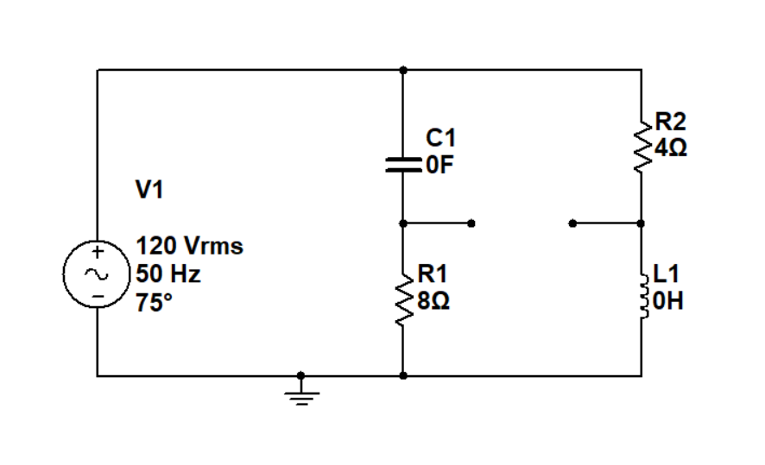

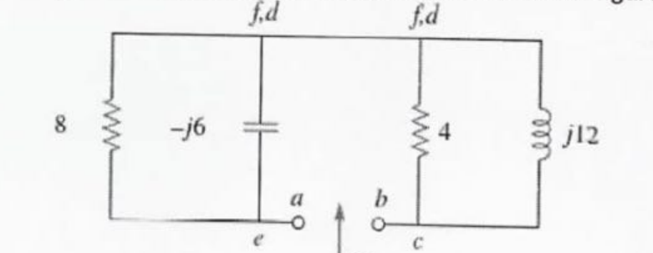

$z_{1}$ = $\frac{8*-j6}{8+j6}$

$z_{2}$ = $\frac{4*j12}{4+j12}$

The thevenin impedance is the series combination of z1 and z2 that is

$z_{th}$ = $z_{2}$ + $z_{2}$ = 6.48 – j 2.64

To find $v_{th}$ consider the circuit in the following figure :

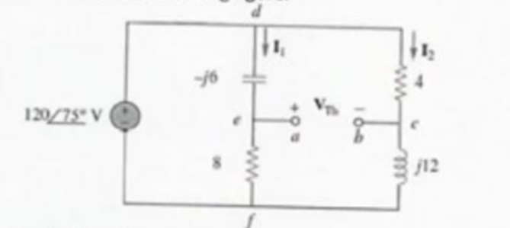

Current 1 and 2 are obtained as

$I_{1}$ = $\frac{120<75}{8-j 6 }$ $I_{2}$ = $\frac{120<75}{4+j 12 }$

Apply KVL around loop bcdeab

- 4 $I_{2}$ + (-j6) $I_{1}$ =0

$v_{th}$ = 4 $I_{2}$ + j6 $I_{1}$ = $\frac{480<75}{4+j 12 }$ + $\frac{720 <75+90}{8-j 6 }$

=37.95< 3.43 + 72< 20.87

-28.93- j 24 .55 = 37 .95< 220.31

Hom work

Find the thevenin equivelent at terminal a-b of the below circuit

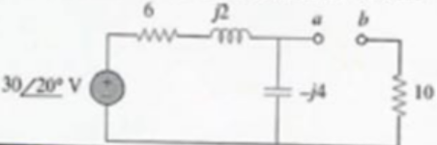

Answer $z_{th}$ = 12.4 – j3.2 $v_{th}$ = 18.97< -51.57

Example : find the thevenin equivalent of the circuit in the figure below as see from terminal a-b

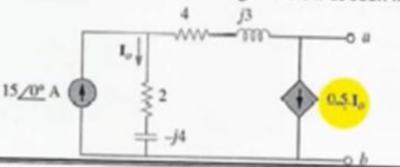

Solution

To find the Vth we apply KCL at node 1 as seen in the below figure

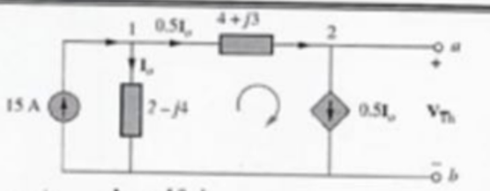

15 = $I_{O}$ + 0.5 $I_{O}$ $I_{O}$ = 10 A

Apply the KVL on the loop

- $I_{O}$ (2-j4 )+ 0.5 $I_{O}$ (4 +j3) + $v_{th}$ =0

$v_{th}$ = 10 (2-j4 )+ 5 (4 +j3) =-j55

= 55<-90

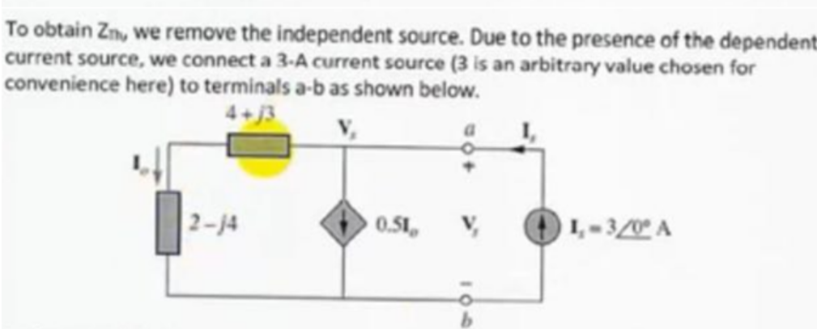

At node KCL given

3= $I_{O}$- 0.5 $I_{O}$ $I_{O}$ = 2A

$V_{S}$ = $I_{O}$ ( 4+ J3 + 2 –J 4) = 2( 6- J )

$Z_{TH}$ = $\frac{V_{S}}{I_{S}}$ = $\frac{2( 6- J ) }{3}$

Norton theorem

Example : obtain current $I_{O}$ in the following network using Norton theorem

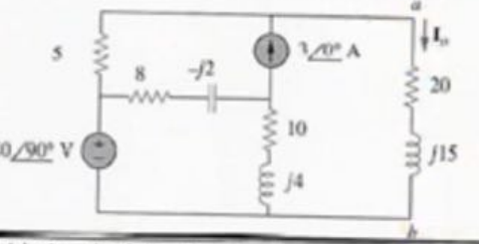

To determine zn we consider the following circuit

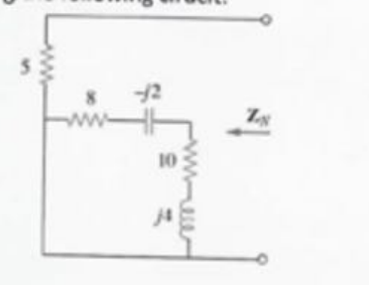

ZN =5 ohm

To get IN we considers the following circuit

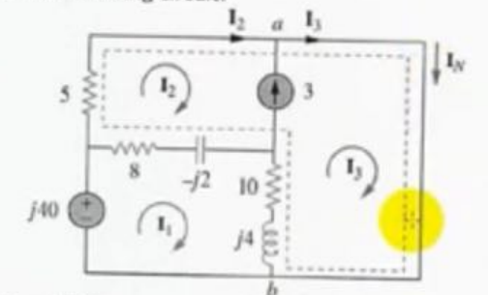

Notice that mesh 2 and 3 from a super mesh because of the current source linking

Them

For the mesh 1

-j40+ (18 +j12) $I_{1}$– (8- j2 ) $I_{2}$–(10 + j4 ) $I_{3}$ =0

For the supermesh

( 13-j2) $I_{1}$– (8 – j2) $I_{2}$–( 18 +j2) $I_{3}$ =0

At node a due the current source between mesh 2 and 3

$I_{3}$ = $I_{2}$ +3

By substitution

-j40 + 5 $I_{2}$ =0 $I_{2}=$ j8

$I_{3}$ = $I_{2}$ +3 = 3 + j8

$I_{N}=I_{3}$ = 3 + j8

$I_{O}=I_{N}$ $\frac{5}{20+J15 }$

$I_{O}=$*

3 + j8 $\frac{5}{20+J15 }$

*