**قــســــــــــم الامــــــــــــــــــــــــــن الــــــــــــــــــــــــــــــــــــسيبرانــــــــــــــــــــــــــــــــــــي**

**Department of Cyber Security**

**MICROPROCESSORS**

**Lecture: (4)**

**microprocessor**

**Class: Second**

**Lecturer: M.Sc.Muntather AL-mussawee**

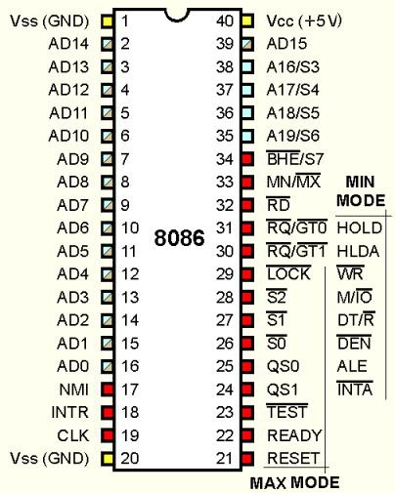

# **Control & Status Signals:**

#  ALE: Address latch enable

#  RD: Read control signal.

#  WR: Write control signal.

#  IO/M, S1 and SO: Status signals

# **Power Supply & Clock Frequency:**

#  Vec: +5 V power supply

#  Vss: Ground reference

#  X1, X2: A crystal having frequency of 6 MHz is connected at these

#  two pins

#  CLK: Clock output

# **Externally Initiated and Interrupt Signals:**

#  RESET IN: When the signal on this pin is low, the PC is set to 0,

#  the buses are tri-stated and the processor is reset.

#  RESET OUT: This signal indicates that the processor is being

# reset. The signal can be used to reset other devices.

#  READY: When this signal is low, the processor waits for an

# integral number of clock cycles until it goes high.

# • HOLD: This signal indicates that a peripheral like DMA (direct

# memory access) controller is requesting the use of address and data bus.

# • HLDA: This signal acknowledges the HOLD request.

# • INTR: Interrupt request is a general-purpose interrupt.

# • INTA: This is used to acknowledge an interrupt.

# • RST 7.5, RST 6.5, RST 5,5 - restart interrupt: These are vectored

# interrupts and have highest priority than INTR interrupt.

# • TRAP: This is a non-maskable interrupt and has the highest priority. •

# Serial I/O Signals:

# • SID: Serial input signal. Bit on this line is loaded to D7 bit of register

# A using RIM instruction.

# • SOD: Serial output signal. Output SOD is set or reset by using SIM

# instruction.

# 

# **INSTRUCTION SET AND EXECUTION IN 8086**

# Based on the design of the ALU and decoding unit, the microprocessor

# manufacturer provides instruction set for every microprocessor. The

# instruction set consists of both machine code and mnemonics.

# An instruction is a binary pattern designed inside a microprocessor to

# perform a specific function. The entire group of instructions that a

# microprocessor supports is called instruction set. Microprocessor

# instructions can be classified based on the parameters such functionality,

# length and operand addressing.

# **Classification based on functionality:**

# **1-Data transfer operations:** This group of instructions copies data

# from source to destination. The content of the source is not altered.

# **2- Arithmetic operations:** Instructions of this group perform

# operations like addition, subtraction, increment & decrement. One

# of the data used in arithmetic operation is stored in accumulator

# and the result is also stored in accumulator.

# **3- Logical operations:** Logical operations include AND, OR, EXOR,

# NOT. The operations like AND, OR and EXOR uses two

# operands, one is stored in accumulator and other can be any

# register or memory location. The result is stored in accumulator.

# NOT operation requires single operand, which is stored in

# accumulator.

# **4- Branching operations:** Instructions in this group can be used to

# transfer program sequence from one memory location to another

# either conditionally or unconditionally.

# 5- Machine control operations: Instruction in this group control

# execution of other instructions and control operations like interrupt, halt

# etc.

# **Memory segmentation:**

# Segmentation is the process in which the main memory of the computer

# is logically divided into different segment and each segment has it own

# base address.

