**كلية العلوم**

**قــســــــــــم الانظمة الطبية الذكية**

**Lecture (3): Image Analysis and preprocessing techniques**

**Subject: Image Processing**

**Level: Third**

**Lecturer:** **Asst. Lecturer Qusai AL-Durrah**

**3.1 Image Analysis**

Image analysis involves manipulating the image data to determine exactly the information necessary to help solve a computer imaging problem. This analysis is typically part of a larger process, is iterative in nature and allows us to answer application specific equations: Do we need color information? Do we need to transform the image data into the frequency domain? Do we need to segment the image to find object information? What are the important features of the image? Image analysis is primarily data reduction process. As we have seen, images contain enormous amount of data, typically on the order hundreds of kilobytes or even megabytes. Often much of this information is not necessary to solve a specific computer imaging problem, so primary part of the image analysis task is to determine exactly what information is necessary. Image analysis is used both computer vision and image processing.

For computer vision, the end product is typically the extraction of high-level information for computer analysis or manipulation. This high-level information may include shape parameter to control a robotics manipulator or color and texture features to help in diagnosis of a skin tumor.

In image processing application, image analysis methods may be used to help determine the type of processing required and the specific parameters needed for that processing. For example, determine the degradation function for an image restoration procedure, developing an enhancement algorithm and determining exactly what information is visually important for image compression methods.

**3.2 System Model**

The image analysis process can be broken down into three primary stages:

1. Preprocessing.

2. Data Reduction.

3. Features Analysis.

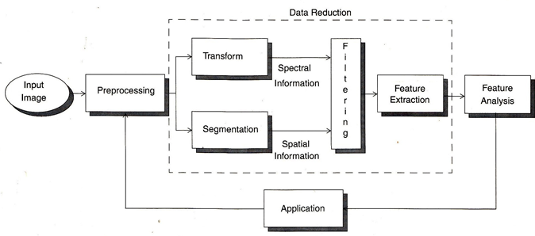

**1. Preprocessing:**

Is used to remove noise and eliminate irrelevant, visually unnecessary information. Noise is unwanted information that can result from the image acquisition process, other preprocessing steps might include:

• Gray –level or spatial quantization (reducing the number of bits per pixel or the image size).

• Finding regions of interest for further processing.

**2. Data Reduction:**

Involves either reducing the data in the spatial domain or transforming it into another domain called the frequency domain, and then extraction features for the analysis process.

**3. Features Analysis:**

The features extracted by the data reduction process are examine and evaluated for their use in the application.

After preprocessing we can perform segmentation on the image in the spatial domain or convert it into the frequency domain via a mathematical transform. After these processes we may choose to filter the image. This filtering process further reduces the data and allows us to extract the feature that we may require for analysis.

**3.3 Preprocessing**

The preprocessing algorithm, techniques and operators are use to perform initial processing that makes the primary data reduction and analysis task easier. They include operations related to:

• Extracting regions of interest.

• Performing basic algebraic operation on image.

• Enhancing specific image features.

• Reducing data in resolution and brightness.

Preprocessing is a stage where the requirements are typically obvious and simple, such as removal of artifacts from images or eliminating of image information that is not required for the application. For example, in one application we needed to eliminate borders from the images that have been digitized from film. Another example of preprocessing step involves a robotics gripper that needs to pick and place an object ; for this we reduce a gray-level image to binary (two-valued) image that contains all the information necessary to discern the object ‘s outlines.

**3.3.1 Region of Interest Image Geometry**

Often, for image analysis we want to investigate more closely a specific area within the image, called region of interest (ROI). To do this we need operation that modifies the spatial coordinates of the image, and these are categorized as image geometry operations. The image geometry operations discussed here include:

Crop , Zoom, enlarge, shrink, translate and rotate. The image crop process is the process of selecting a small portion of the image, a sub image and cutting it away from the rest of the image. After we have cropped a sub image from the original image we can zoom in on it by enlarge it. The zoom process can be done in numerous ways:

**1. Zero-Order Hold.**

**2. First _Order Hold.**

**3. Convolution.**

1. **Zero-Order hold:** is performed by repeating previous pixel values, thus creating a blocky effect as in the following figure:

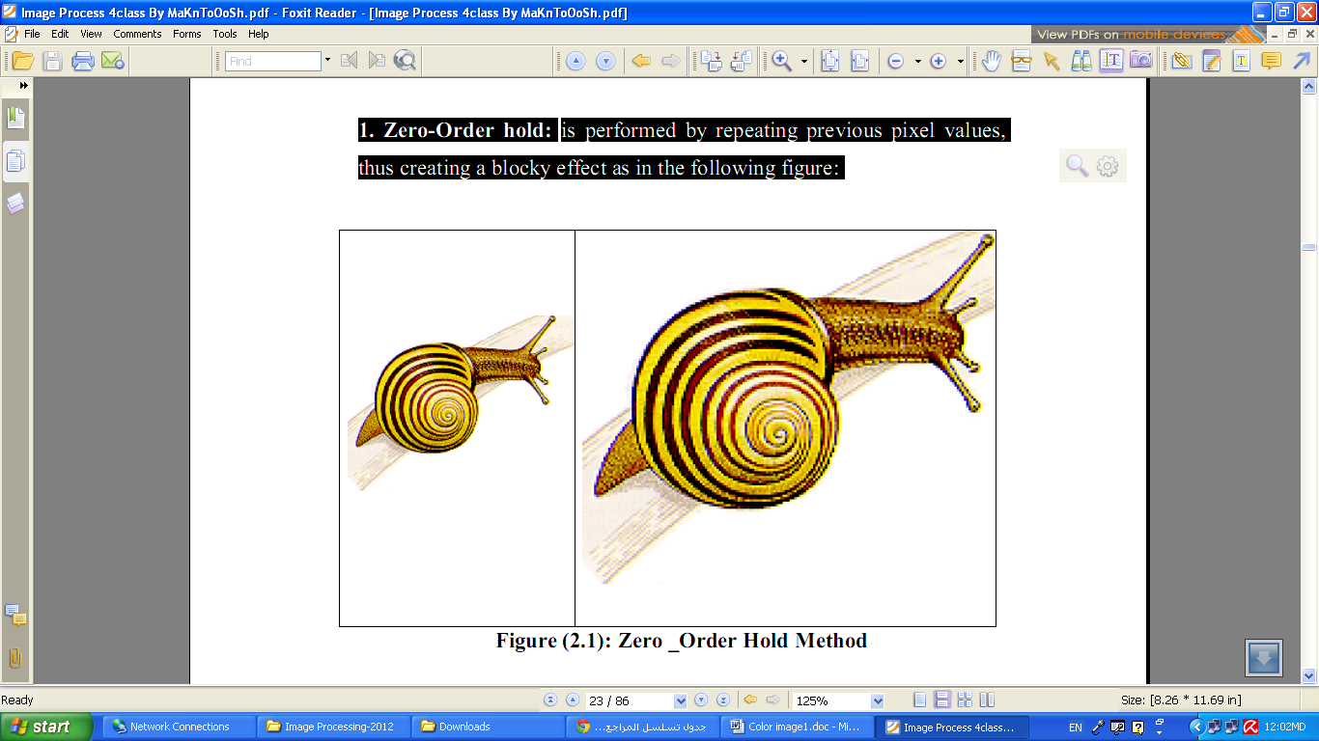

Figure (3.1): Zero _Order Hold Method

**2. First _Order Hold:** is performed by finding linear interpolation between adjacent pixels, i.e., finding the average value between two pixels and use that as the pixel value between those two, we can do this for the rows first as follows:

Original Image Array Image with Rows Expanded

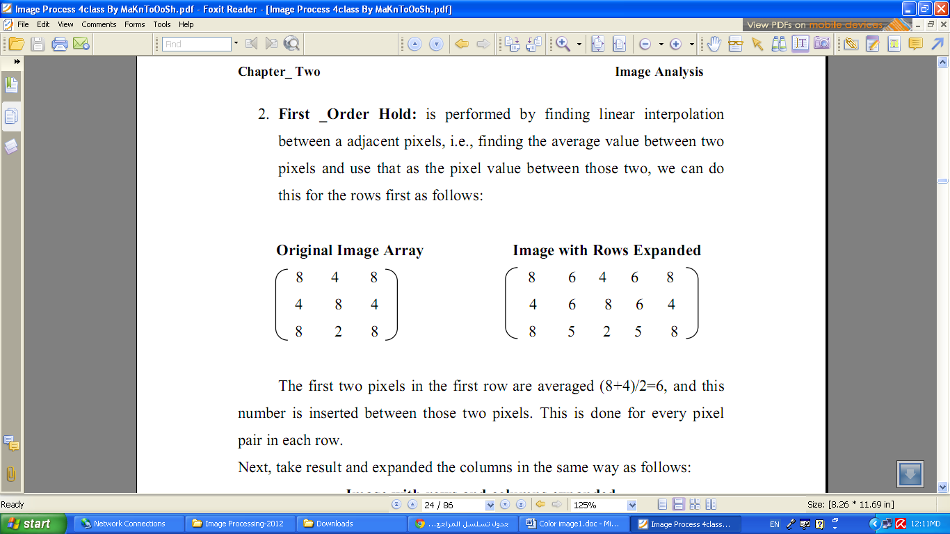

The first two pixels in the first row are averaged (8+4)/2=6, and this number is inserted between those two pixels. This is done for every pixel pair in each row.

Next, take result and expanded the columns in the same way as follows:

Image with rows and columns expanded

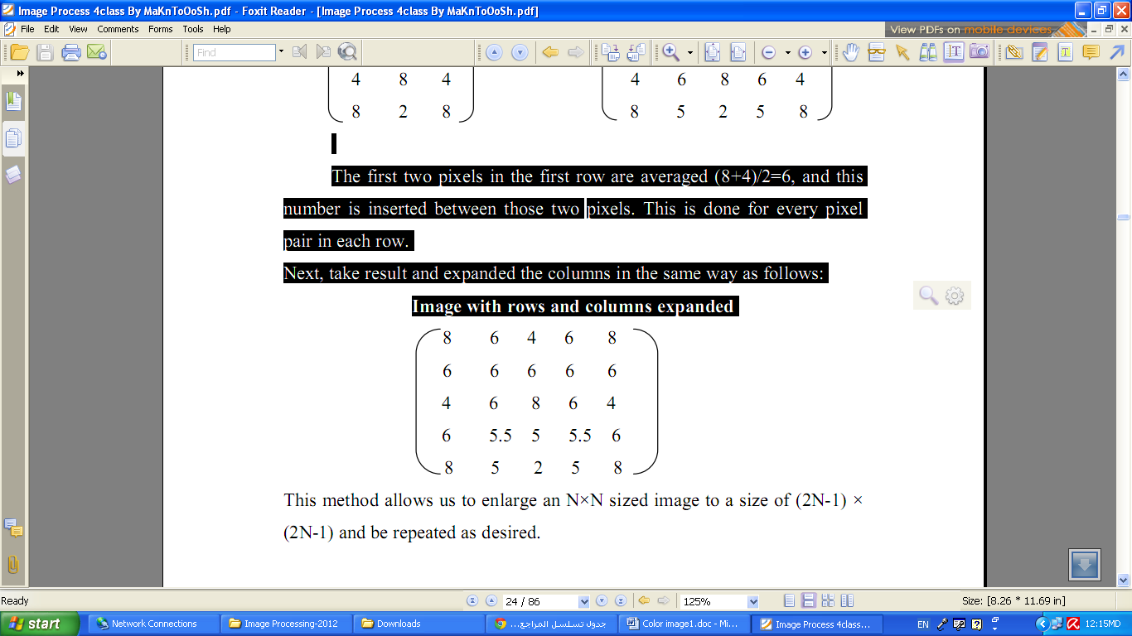

This method allows us to enlarge an N×N sized image to a size of (2N-1) × (2N-1) and be repeated as desired.