**كلية العلوم**

**قــســــــــــم الانظمة الطبية الذكية**

**Lecture (1): introduction to image processing**

**Subject: image processing**

**Level: Third**

**Lecturer:** **Asst. Lecturer Qusai AL-Durrah**

**1.1 Computer Imaging**

Can be defined an acquisition and processing of visual information by computer. Computer representation of an image requires the equivalent of many thousands of words of data, so the massive amount of data required for image is a primary reason for the development of many sub areas with field of computer imaging, such as image compression and segmentation. Another important aspect of computer imaging involves the ultimate “receiver” of visual information in some case the human visual system and in some cases the human imaging can be separate into two primary categories:

1. Computer Vision.
2. Image Processing.

(In computer vision application the processed images output for use by a computer, whereas in image processing applications the output images are for human consumption).

These two categories are not totally separate and distinct. The boundaries that separate the two are fuzzy, but this definition allows us to explore the differences between the two and to understand how they fit together (Figure 1.1).

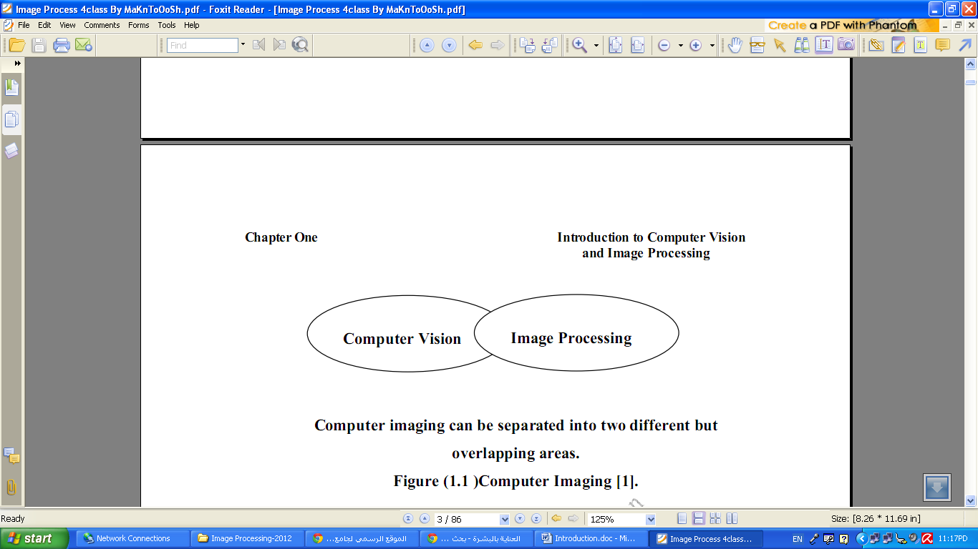

Computer imaging can be separated into two different but

overlapping areas.

Figure (1.1) Computer Imaging.

Historically, the field of image processing grew from electrical engineering as an extension of the signal processing branch, whereas are the computer science discipline was largely responsible for developments in computer vision.

**1.2 Computer Vision**

Computer vision computer imaging where the application doses not involve a human being in visual loop (image to model). One of the major topics within this field of computer vision is image analysis (Figure (1.1)).

1. **Image Analysis:** involves the examination of the image data to facilitate solving vision problem.

The image analysis process involves two other topics:

**• Feature Extraction:** is the process of acquiring higher level image information, such as shape or color information.

**• Pattern Classification:** is the act of taking this higher –level information and identifying objects within the image.

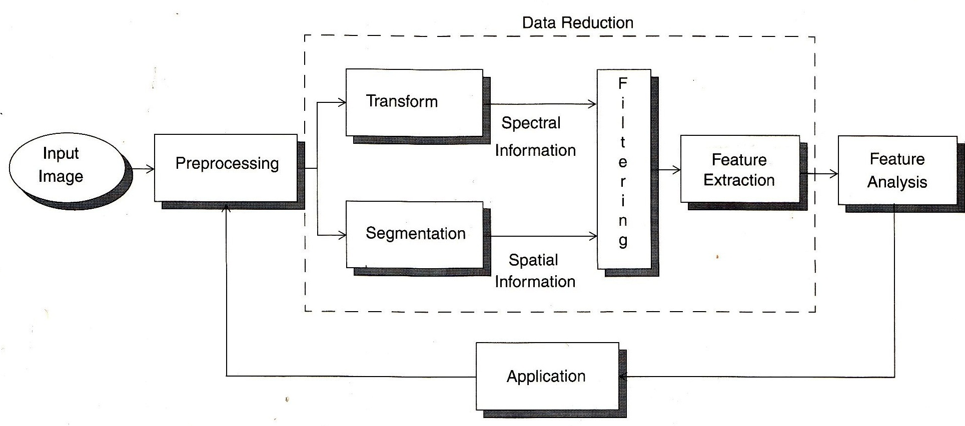

Figure (1.2) image analysis

Computer vision systems are used in many and various types of environments, such as:

1. Manufacturing Systems

2. Medical Community

3. Law Enforcement

4. Infrared Imaging

5. Satellites Orbiting.

**1.3 Image Processing**

Image processing is computer imaging where application involves a human being in the visual loop (image to image). In other words the image is to be examined and acted upon by people.

The major topics within the field of image processing include:

1. Image restoration.

2. Image enhancement.

3. Image compression.

**1.3.1 Image Restoration**

Is the process of taking an image with some known, or estimated degradation, and restoring it to its original appearance. Image restoration is often used in the field of photography or publishing where an image was somehow degraded but needs to be improved before it can be printed(Figure 1.3).

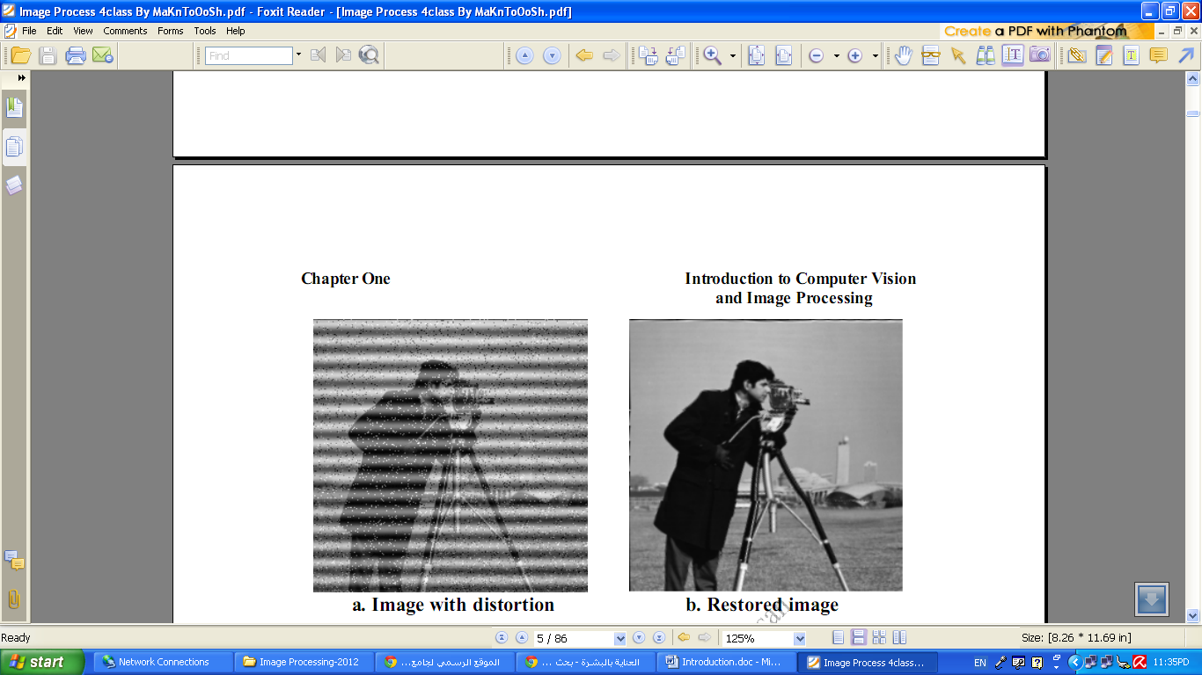

Figure (1.3) Image Restoration

**1.3.2 Image Enhancement**

Involves taking an image and improving it visually, typically by taking advantages of human Visual Systems responses. One of the simplest enhancement techniques is to simply stretch the contrast of an image.

Enhancement methods tend to be problem specific. For example, a method that is used to enhance satellite images may not suitable for enhancing medical images.

Although enhancement and restoration are similar in aim, to make an image look better. They differ in how they approach the problem. Restoration method attempt to model the distortion to the image and reverse the degradation, where enhancement methods use knowledge of the human visual systems responses to improve an image visually.

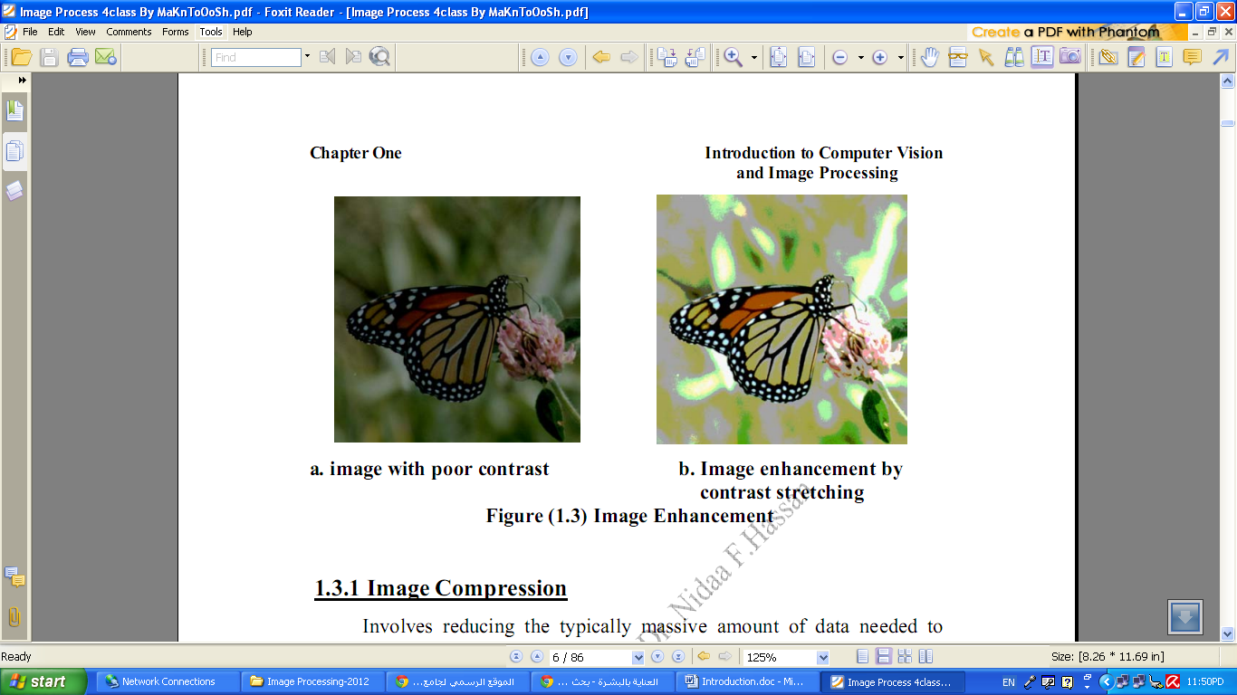

a. image with poor contrast b. Image enhancement by contrast stretching

Figure (1.4) Image Enhancement

**1.3.1 Image Compression**

Involves reducing the typically massive amount of data needed to represent an image. This done by eliminating data that are visually unnecessary and by taking advantage of the redundancy that is inherent in most images.

Image processing systems are used in many and various types of environments, such as:

1. Medical community

2. Computer – Aided Design

3. Virtual Reality

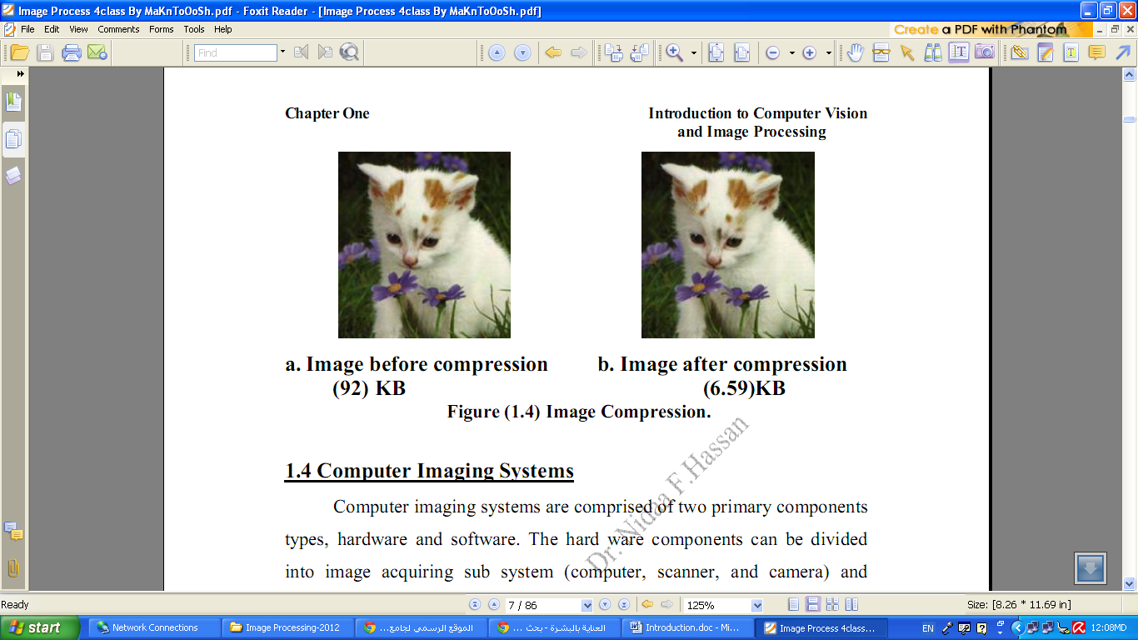

a. Image before compression b. Image after compression

(92) KB (6.59) KB

Figure (1.5) Image Compression.

**1.4 Computer Imaging Systems**

Computer imaging systems are comprised of two primary components types, hardware and software. The hardware components can be divided into image acquiring sub system (computer, scanner, and camera) and display devices (monitor, printer).The software allows us to manipulate the image and perform any desired processing on the image data.

**1.5 Digitization**

The process of transforming a standard video signal into digital image. This transformation is necessary because the standard video signal in analog (continuous) form and the computer requires a digitized or sampled version of that continuous signal. The analog video signal is turned into a digital image by sampling the continuous signal at affixed rate. In the figure below we see one line of a video signal being sampled (digitized) by instantaneously measuring the voltage of the signal at fixed intervals in time.

The value of the voltage at each instant is converted into a number that is stored, corresponding to the brightness of the image at that point.

Note that the image brightness of the image at that point depends on both the intrinsic properties of the object and the lighting conditions in the scene.

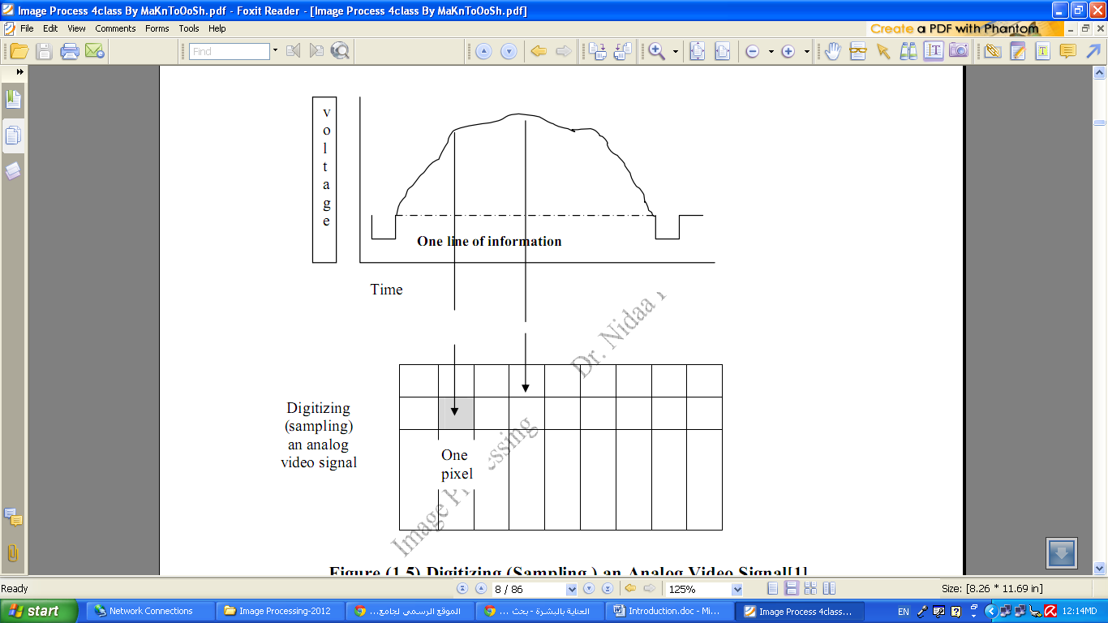

Figure (1.6): Digitizing (Sampling) an Analog Video Signal

The image can now be accessed as a two-dimension array of data, where each data point is referred to a pixel (picture element) for digital images we will use the following notation:

I(r,c) = The brightness of image at the point (r,c)

Where r= row and c= column.

“When we have the data in digital form, we can use the software to process the data”.

The digital image is 2D- array as:

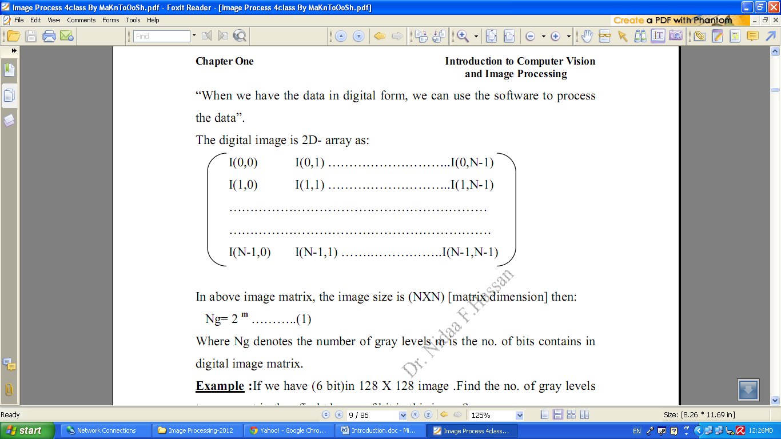

In above image matrix, the image size is (NXN) [matrix dimension] then:

Ng= 2­ ……….. (1)

Where Ng denotes the number of gray levels m is the no. of bits contains in digital image matrix.

**Example:** If we have (6 bit) in 128 X 128 image. Find the no. of gray levels to represent it ,then find the no. of bit in this image?

Solution:

Ng= 2= 64 Gray Level

Nb = 128 * 128* 6 = 9.8304 * 10 bit

**1.6 The Human Visual System**

The Human Visual System (HVS) has two primary components:

* Eye.
* Brian.

* The structure that we know the most about is the image receiving sensors (the human eye).

* The brain can be thought as being an information processing unit analogous to the computer in our computer imaging system.

These two are connected by the optic nerve, which is really a bundle of nerves that contains the path ways for visual information to travel from the receiving sensor (the eye) to the processor (the brain).