Digestive Tract (GIT) General Review & Surgical Approaches

**Part 1: General Review of the Digestive Tract**

The digestive tract is a continuous muscular tube extending from the mouth to the anus, approximately 9 meters (30 feet) in length. Its primary functions are ingestion, digestion, absorption, and elimination.

**Anatomical Divisions and Key Functions**

1. **Mouth & Pharynx:** Mechanical breakdown (mastication) and initiation of chemical digestion (amylase). The pharynx is a common pathway for air and food.
2. **Esophagus:** A muscular conduit that transports food from the pharynx to the stomach via peristalsis. It passes through the diaphragm at the **esophageal hiatus**.
3. **Stomach:** Acts as a food reservoir. It secretes hydrochloric acid and pepsin for protein digestion. Churns food into a semi-liquid substance called chyme.
4. **Small Intestine:** The primary site for digestion and absorption. Divided into three parts:
   * **Duodenum:** Short, fixed, C-shaped segment receiving chyme, bile (from liver/gallbladder), and pancreatic enzymes.
   * **Jejunum:** The primary site for nutrient absorption in the upper abdomen.
   * **Ileum:** Absorbs bile salts and vitamin B12. Empties into the large intestine at the **ileocecal valve**.
5. **Large Intestine (Colon):** Primarily absorbs water and electrolytes, storing and forming feces. Divided into:
   * **Cecum & Appendix:** The pouch at the beginning of the large intestine.
   * **Ascending, Transverse, Descending, and Sigmoid Colon:** Frame the abdominal cavity.
   * **Rectum:** Stores feces until defecation.
   * **Anal Canal:** The terminal end with sphincters for voluntary and involuntary control. 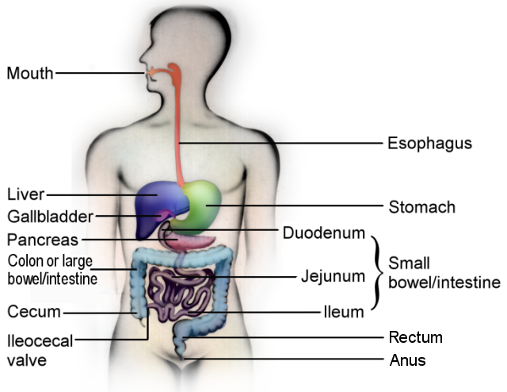

**Part 2: Surgical Approaches to the Digestive Tract**

Surgical intervention is required for a wide range of conditions, including cancer, obstruction, perforation, ischemia, and inflammatory diseases (like Crohn's or Ulcerative Colitis). The approach is dictated by the target organ, the disease process, and patient factors.

**Overarching Principles**

* **Goal:** The primary goals are to remove diseased tissue (resection), restore continuity (anastomosis), or divert the fecal stream (ostomy).
* **Exposure:** Gaining safe and adequate access to the target organ is the first step.
* **Oncologic Principles:** For cancer surgery, the goal is an **R0 Resection** (complete removal with negative margins), often including the associated lymph nodes and blood supply (e.g., **D3 Lymphadenectomy** in colon cancer).

**Access to the Abdomen: Incisions**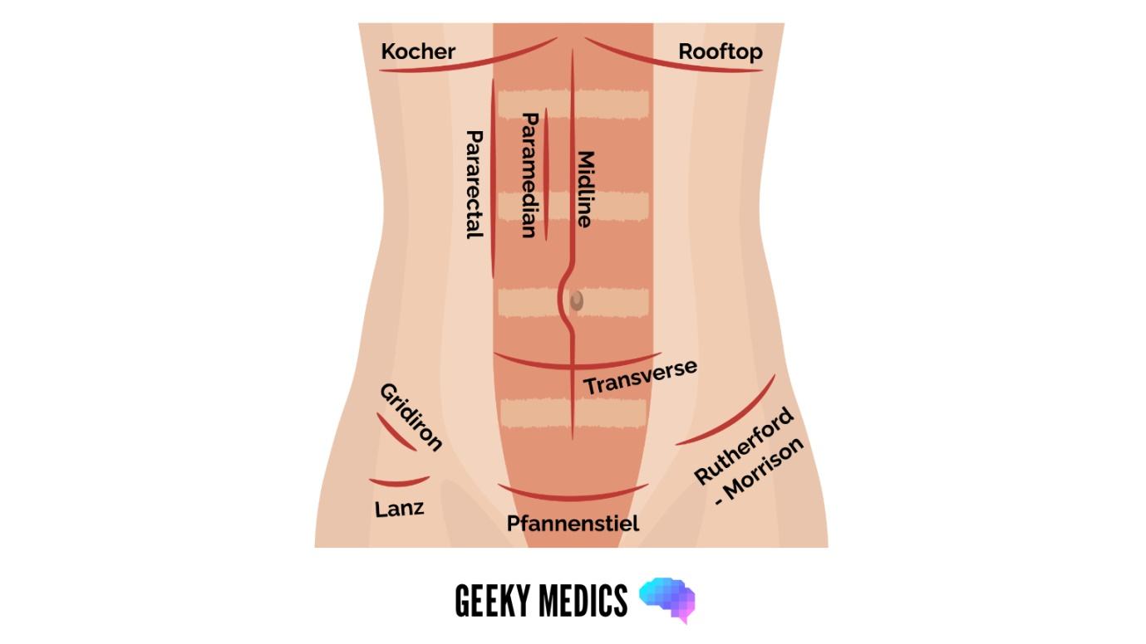

The choice of incision is a balance between exposure, healing, and cosmesis.

| Incision Type | Location/Description | Common Use |
| --- | --- | --- |
| **Midline** | Vertical, through the linea alba. | **Most common.** Provides rapid, wide access to the entire abdomen. Excellent for trauma and emergency surgery. |
| **Transverse** | Horizontal, often following skin lines (Langer's lines). | Better cosmesis, less post-op pain. Used for specific organs (e.g., Pfannenstiel incision for pelvic surgery). |
| **Subcostal (Kocher)** | Right or left upper quadrant, parallel to and below the costal margin. | Access to gallbladder, liver, or spleen. |
| **Paramedian** | Vertical, lateral to the midline (less common now). | Historical use for gastric/duodenal surgery. |

**Surgical Techniques: Open vs. Minimally Invasive Surgery (MIS)**

1. **Open Surgery:** The traditional approach using a single large incision. It offers excellent exposure and tactile feedback, which is crucial in complex or unstable cases.
2. **Minimally Invasive Surgery (MIS):** Characterized by smaller incisions, less pain, and faster recovery.
   * **Laparoscopy:** The standard for many GIT procedures. A camera (laparoscope) is inserted through a small port, and long instruments are used through other ports. Examples: Laparoscopic Cholecystectomy, Appendectomy, Colectomy.
   * **Robotic-Assisted Surgery:** A surgeon controls robotic arms from a console. Offers 3D vision, wristed instruments for enhanced dexterity, and tremor filtration. Commonly used for prostatectomy, but increasingly for complex colorectal, foregut, and hepatopancreatobiliary (HPB) surgery.

**Critical Surgical Maneuvers**

* **Anastomosis:** The surgical connection of two tubular structures (e.g., two ends of bowel after a resection). Can be hand-sewn with sutures or created with a stapling device. Leakage is a major complication.
* **Ostomy:** Creating an opening (stoma) of the bowel onto the abdominal skin. Used to divert fecal flow.
  + **Ileostomy:** From the ileum. Liquid output.
  + **Colostomy:** From the colon. More formed output. Can be temporary (to protect a distal anastomosis) or permanent (after APR).

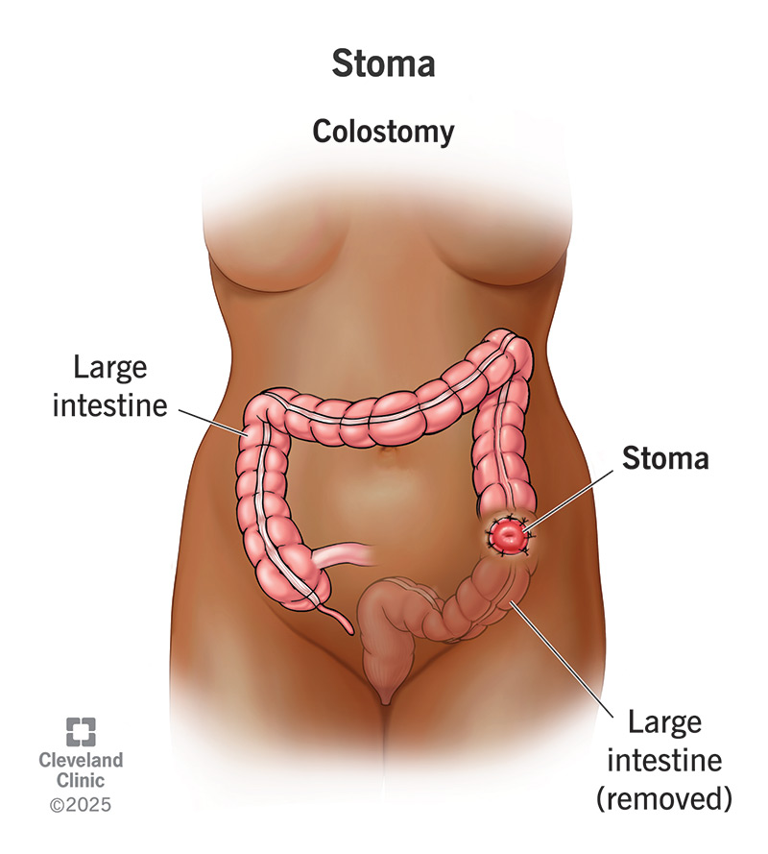**Summary**

The field of gastrointestinal surgery has evolved dramatically from large, open procedures to highly specialized, minimally invasive techniques. A deep understanding of anatomy—including the relationships between organs, their blood supply, and their peritoneal attachments—is the absolute foundation for any surgical approach. The choice of technique is always tailored to provide the best oncologic or functional outcome with the least morbidity for the patient.