**قــســــــــــم الامــــــــــــــــــــــــــن الــــــــــــــــــــــــــسيبرانــــــــــــــــــــــــــــــــــــي**

**Department of Cyber Security**

**Subject:**

**Object Oriented Programming (OOP)**

**Class:**

**Second**

**Lecturer:**

**Dr. Abdulkadhem A. Abdulkadhem**

**Lecture: (1)**

**Back to Basics: Revisiting Key C++ Principles**

**Programming** is the process of writing instructions for a computer in a certain order to solve a problem.

**Special Characters:** In C++ , all characters other than listed treated as special characters for example:

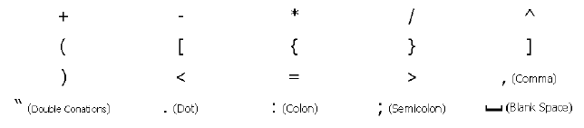

**Reserved words** cannot be used as variable names or constant. The following words are reserved for use as keywords:

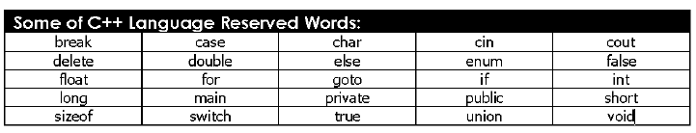

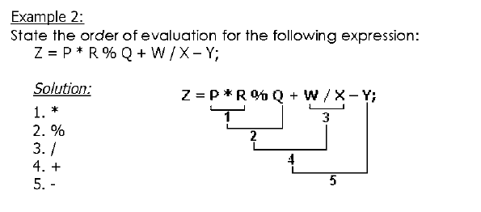

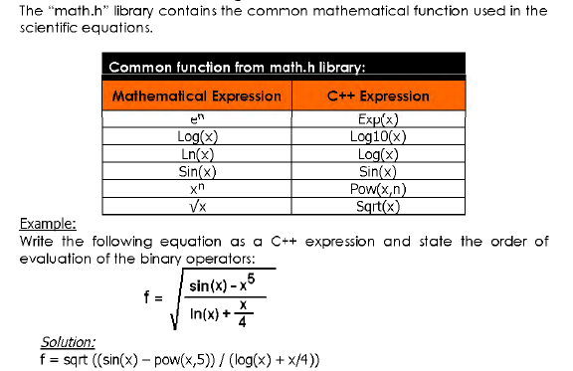

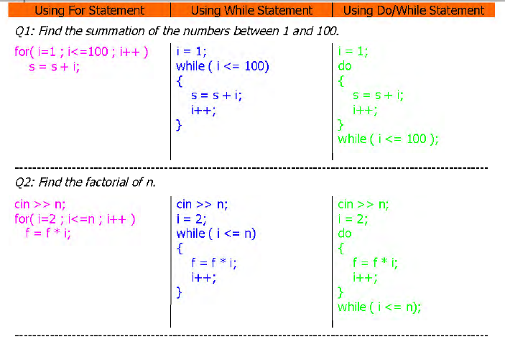

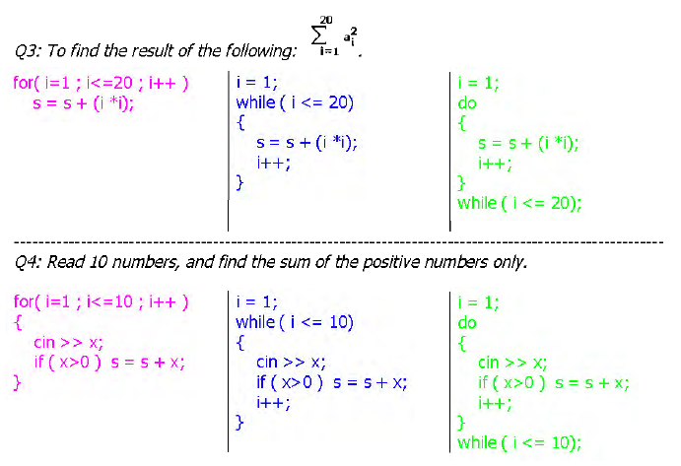

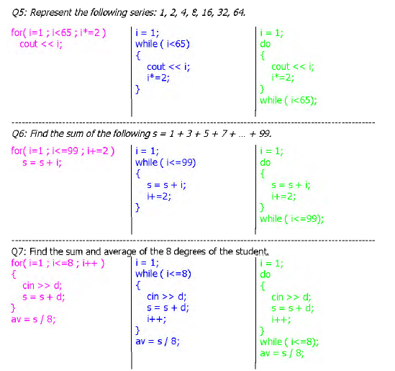

**Structures** are typically used to group several data items together to form a single entity. It is a collection of variables used to group variables into a single record. Thus a structure (the keyword struct is used in C++) is used. Keyword struct is a data-type, like the following C++ data-types ( int, float, char, etc ... ). This is unlike the array, which all the variables must be the same type. The data items in a structure are called the members of the structure.

