Lecture No.: 6
The Biomechanics of the Human Lower Extremity
STRUCTURE OF THE HIP
The hip is a ball-and-socket joint (Figure 1). The ball is the head of the femur, which forms approximately two-thirds of a sphere. The socket is the concave acetabulum, which is angled obliquely in an anterior, lateral, and inferior direction. Joint cartilage covers both articulating surfaces. The cartilage on the acetabulum is thicker around its periphery, where it merges with a rim, or labrum, of fibrocartilage that contributes to the stability of the joint.
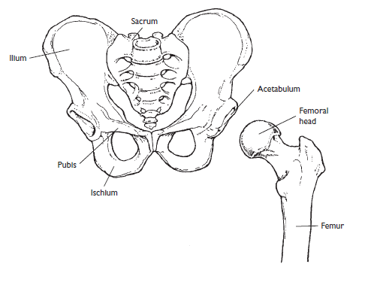
Figure 1: The bony structure of the hip

MOVEMENTS AT THE HIP
Flexion
The six muscles primarily responsible for flexion at the hip are those crossing the joint anteriorly: the iliacus, psoas major, pectineus, rectus femoris, sartorius, and tensor fascia latae. Of these, the large iliacus and psoas major often referred to jointly as the iliopsoas because of their common attachment to the femur are the major hip flexors (Figure 2). Because the rectus femoris is a two-joint muscle active during both hip flexion and knee extension, it functions more effectively as a hip flexor when the knee is in flexion, as when a person kicks a ball.
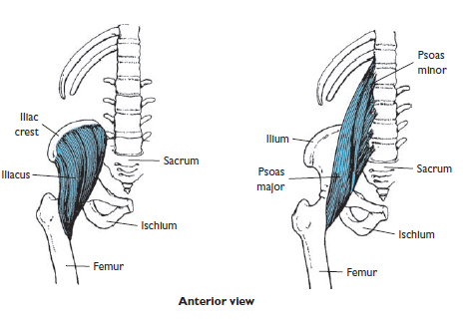
Figure 2: The iliopsoas complex is the major flexor of the hip
Extension
The hip extensors are the gluteus maximus and the three hamstrings the biceps femoris, semitendinosus, and semimembranosus (Figure 3). The gluteus maximus is a massive, powerful muscle that is usually active only when the hip is in flexion, as during stair climbing or cycling, or when extension at the hip is resisted.
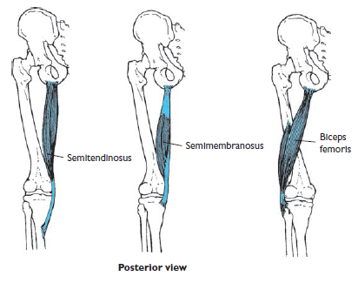
Figure 3: The hamstrings are major hip extensors and knee flexors
Abduction
The gluteus medius is the major abductor acting at the hip, with the gluteus minimus assisting. These muscles stabilize the pelvis during the support phase of walking and running and when an individual stands on one leg.
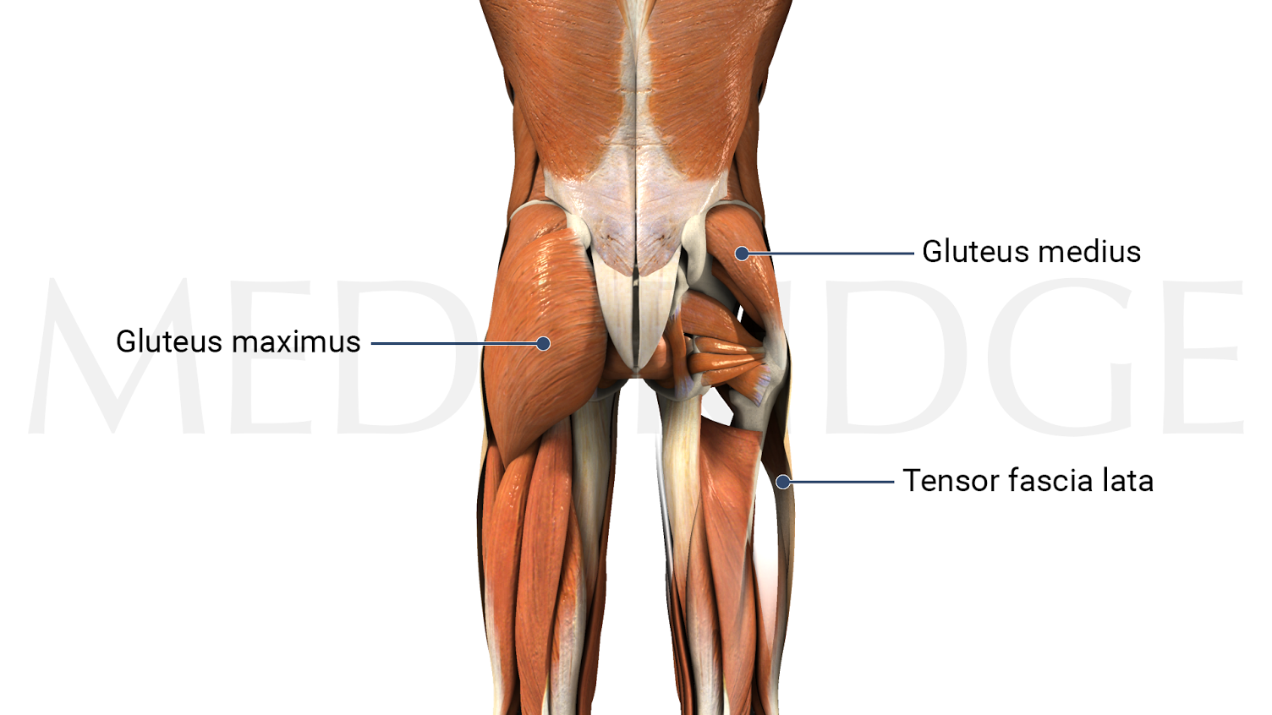
Figure 3: The gluteus medius muscles

Adduction
The hip adductors are those muscles that cross the joint medially and include the adductor longus, adductor brevis, adductor magnus, and gracilis (Figure 4).
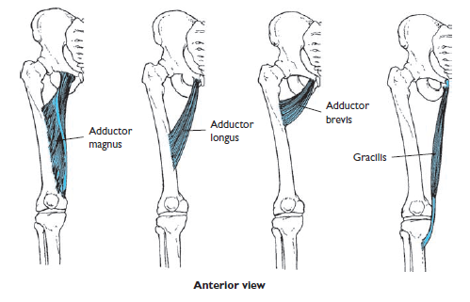
Figure 4: Adductor muscles of the hip
Medial and Lateral Rotation of the Femur
Although a number of muscles contribute to lateral rotation of the femur, six muscles function solely as lateral rotators. These are the piriformis, gemellus superior, gemellus inferior, obturator internus, obturator externus, and quadratus femoris (Figure 5).
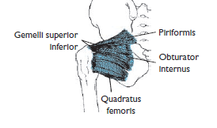
Figure 5: The lateral rotator muscles of the femur

STRUCTURE OF THE KNEE
Tibiofemoral Joint
The medial and lateral condyles of the tibia and the femur articulate to form two side-by-side condyloid joints (Figure 6). These joints function together primarily as a modifi ed hinge joint because of the restricting ligaments, with some lateral and rotational motions allowed. The condyles of the tibia, known as the tibial plateaus, form slight depressions separated by a region known as the intercondylar eminence. Because the medial and lateral condyles of the femur differ somewhat in size, shape, and orientation, the tibia rotates laterally on the femur during the last few degrees of extension to produce “locking” of the knee. This phenomenon, known as the “screw-home” mechanism, brings the knee into the close-packed position of full extension.
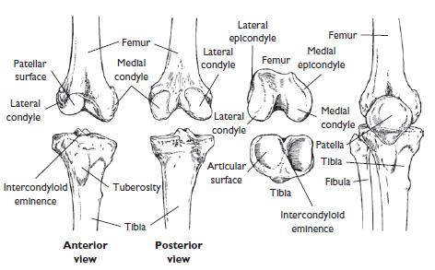
Figure 6: The bony structure of the tibiofemoral joint

Menisci
The menisci, also known as semilunar cartilages after their half-moon shapes, are discs of fibrocartilage firmly attached to the superior plateaus of the tibia by the coronary ligaments and joint capsule (Figure 7).
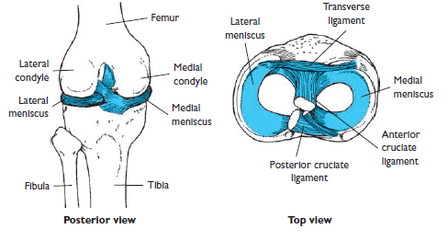
Figure 7: The menisci of the knee
Ligaments
Many ligaments cross the knee, signifi cantly enhancing its stability (Figure 8). The location of each ligament determines the direction in which it is capable of resisting the dislocation of the knee. The medial and lateral collateral ligaments prevent lateral motion at the knee, as do the collateral ligaments at the elbow. They are also respectively referred to as the tibial and fibular collateral ligaments, after their distal attachments. Fibers of the medial collateral ligament complex merge with the joint capsule and the medial meniscus to connect the medial epicondyle of the femur to the medial tibia.
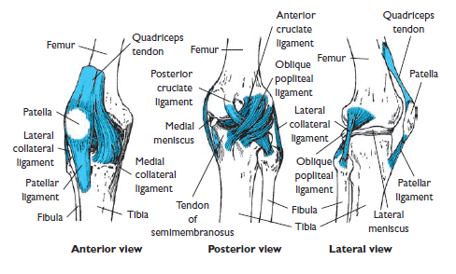
Figure 8: The ligaments of the knee

MOVEMENTS AT THE KNEE
Flexion and Extension
Flexion and extension are the primary movements permitted at the tibiofemoral joint. For flexion to be initiated from a position of full extension, however, the knee must first be “unlocked.” In full extension, the articulating surface of the medial condyle of the femur is longer than that of the lateral condyle, rendering motion almost impossible. The service of locksmith is provided by the popliteus, which acts to medially rotate the tibia with respect to the femur, enabling flexion to occur (Figure 9).
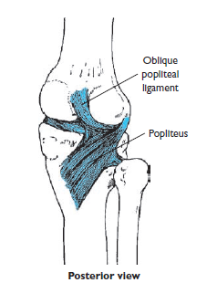
Figure 9: The popliteus muscle is the Oblique locksmith of the knee
Rotation and Passive Abduction and Adduction
Rotation of the tibia relative to the femur is possible when the knee is in flexion and not bearing weight, with rotational capability greatest at approximately 90° of flexion.
STRUCTURE OF THE ANKLE
The ankle region includes the distal tibiofibular, tibiotalar, and fibulotalar joints (Figure 10). The distal tibiofibular joint is a syndesmosis where dense fibrous tissue binds the bones together. The joint is supported by the anterior and posterior tibiofibular ligaments, as well as by the crural interosseous tibiofibular ligament. Most motion at the ankle occurs at the tibiotalar hinge joint, where the convex surface of the superior talus articulates with the concave surface of the distal tibia. All three articulations are enclosed in a joint capsule that is thickened on the medial side and extremely thin on the posterior side.
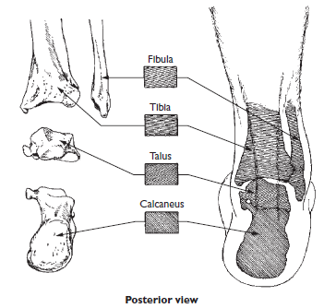
Figure 10: The bony structure of the ankle
STRUCTURE OF THE FOOT
Like the hand, the foot is a multibone structure. It contains a total of 26 bones with numerous articulations (Figure 11).
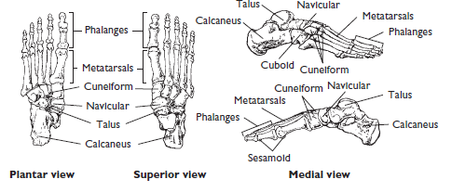
Figure 11: The bony structure of the ankle

