**Respiratory system**

**Respiration**

It is the exchange of gases between the atmosphere, lungs, blood, and tissues; where the oxygen (O2) is taken in and carbon dioxide (Co2) is given out.

**Types of Respiration**

Respiration is often classified into two types:

1. External respiration that involves exchange of respiratory gases, i.e. O2 and Co2 between lungs and blood.

2. Internal respiration which involves exchange of gases between blood and tissues.

**Stages of Respiration**

1. Inspiration during the air enters the lungs from atmosphere

2. Expiration during the air leaves the lungs.

The term respiration includes 4 basic separate processes:

**1. Pulmonary ventilation= (breathing)**

It is the inhalation (inflow) & exhalation (outflow) of air. Involve the exchange of air between the atmosphere and lungs alveoli (in and out).

**2. External respiration (pulmonary) within the lungs**.

It is exchange of gases between lung's alveoli &blood in pulmonary capillaries (of respiratory membrane) which gains 02 and loses Co2.

**3. Transport of respiratory gases=via the blood)**.

Oxygen and carbon dioxide transported to and from the lungs and tissue cells of the body via the bloodstream.

**4. Internal respiration= (cellular respiration)**

Within the tissue "O2 utilization" It is exchange of gases between blood in systemic capillary& tissue cells

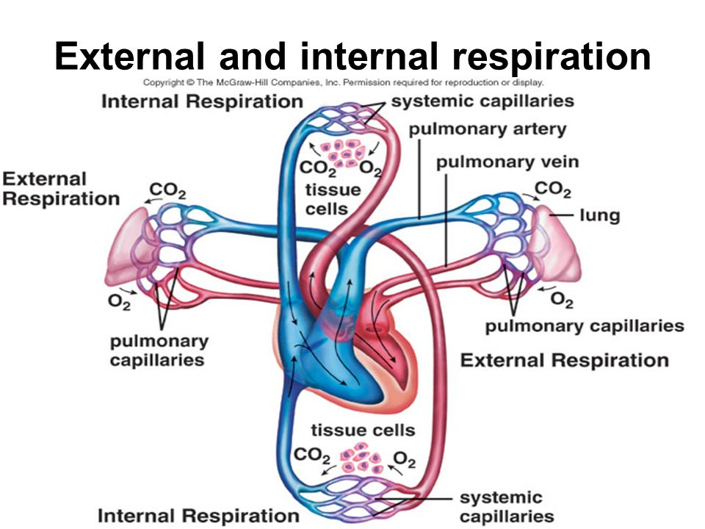

**Respiratory tract**

Respiratory tract is the anatomical structure through which air moves in and out. The organs of the Respiratory Tract" can be divided into two groups "STRUCTURALLY"

**The upper Respiratory tract:**

* Nose
* Nasal cavity
* Sinuses
* Pharynx
* Larynx

**The Lower Respiratory tract:**

* Trachea
* Bronchial Tree
* Lungs

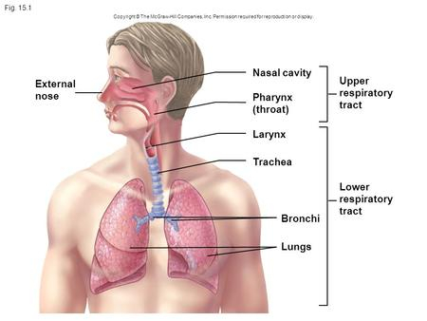

The organs of the "Respiratory Tract" can be divided into two groups "FUNCTIONALLY":

**1- The Conducting Portion** system of interconnecting cavities and tubes that conduct air into the lungs

* Nose
* Pharynx
* Larynx
* Trachea
* Bronchi

**2-The Respiratory Portion** system where the exchange of respiratory gases occurs

* Respiratory bronchioles
* Alveolar Ducts
* Alveoli

**The lung**

1. It is the main organ of the respiratory system. The paired soft, spongy, cone-shaped lungs separated medially and are enclosed by the diaphragm and thoracic cage.
2. Each lung is enclosed by a bilayered serous membrane called pleura or pleural sac. The two layers of pleura are: the visceral (inner) layer lines the surface of the lungs; It is continuous with parietal (outer) layer, which is attached to the wall of the thoracic cavity.
3. The narrow space in between the two layers of pleura is called intrapleural space or pleural cavity. Its space contains a thin film of pleural fluid which is involved in the creating the negative pressure called intrapleural pressure within intrapleural space.

**Tracheobronchial Tree**

1. The trachea and bronchi are together called tracheobronchial tree. It forms a part of air passage.
2. The trachea bifurcates into two main or primary bronchi called right and left bronchi. Each primary bronchus enters the lungs and divides into secondary bronchi, these divide into tertiary bronchi. The tertiary bronchi divide several times and the latest called terminal bronchiole. Terminal bronchiole continues or divides into respiratory bronchiole.

**Respiratory unit**

1. Respiratory unit is defined as the structural and functional unit of lung. The exchange of gases occurs only in this part of the respiratory tract
2. The respiratory unit starts from the respiratory bronchioles. Each respiratory bronchiole divides into alveolar ducts. Each alveolar duct enters an enlarged structure called the alveolar sac. The space inside the alveolar sac is called antrum. Alveolar sac consists of a cluster of alveoli.

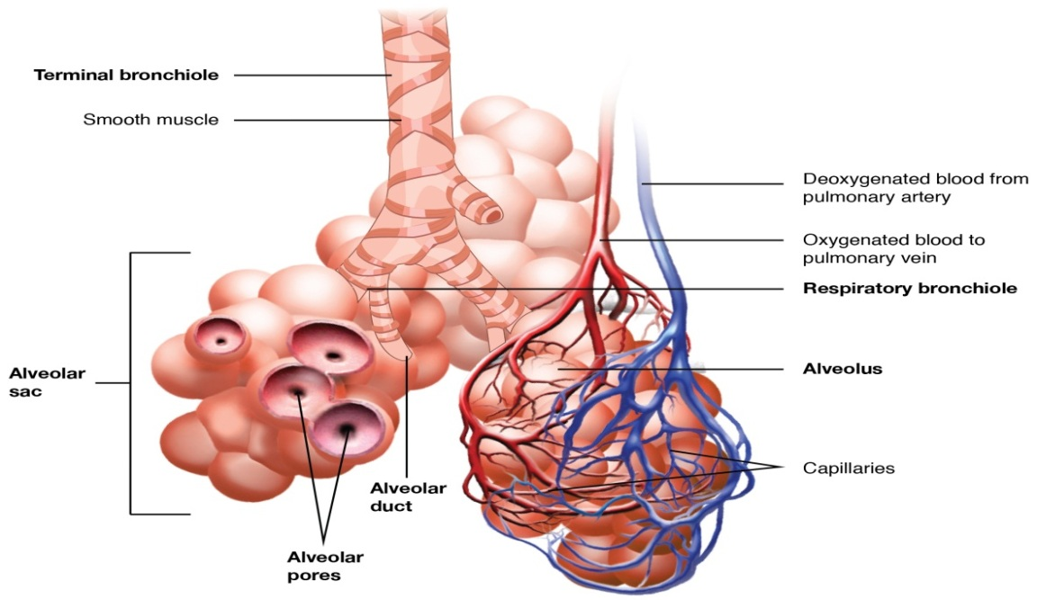

Thus, Respiratory unit includes:

1. Respiratory bronchioles.

2. Alveolar ducts.

3. Alveolar sacs.

4. Antrum.

5. Alveoli.

**Non respiratory functions of respiratory tract**

Besides the primary function of gaseous exchange, the respiratory tract is involved in several non-respiratory functions of the body:

**1. Olfaction**

Olfactory receptors present in the mucous membrane of nostril are responsible for olfactory sensation.

**2. Vocalization**

Along with other structures, larynx forms the speech apparatus.

**3. Prevention of dust particles**

The dust particles, which enter the nostrils from air, are prevented from reaching the lungs by filtration action of the hairs in nasal mucous membrane. The small particles are held by the mucus secreted by the nasal mucous membrane. The smallest particles are removed by the phagocytic action of the macrophages in the alveoli. The particles which escape the protective mechanisms in nose and alveoli are thrown out by cough reflex and sneezing reflex.

**4. Defense mechanism**

This is performed by their defenses and by the presence of various types of cells (leukocytes, macrophages, mast cells, natural killer cells and dendritic cells) in the This mucous membrane lining the alveoli of lungs.

**5. Maintenance of water balance**

Respiratory tract plays a role in water loss mechanism. During expiration, water evaporates through the expired air and some amount of body water is lost.

**6. Regulation of body temperature**

During expiration, along with water, heat is also lost from the body. Thus, respiratory tract plays a role in heat loss mechanism.

**7. Regulation of acid-base balance**

Lungs play a role in maintenance of acid-base balance of the body by regulating the carbon dioxide content in blood.

**8. Anticoagulant function**

Mast cells in lungs secrete heparin; which is an anticoagulant.

**9. Secretion of angiotensin converting enzyme.**

Endothelial cells of the pulmonary capillaries secrete the angiotensin converting enzyme (ACE). It converts the angiotensin I into active angiotensin II which plays an important role in the regulation of blood pressure.

**10. Synthesis of hormonal substances**

Lung tissues are also known to synthesize the hormonal substances, which have many physiological actions in the body including regulation of blood pressure.

**Mechanics of Pulmonary Ventilation:**

The lungs can be expanded and contracted in two ways:

1. By downward and upward movement of diaphragm to lengthen or shorten the chest cavity

2. By elevation and depression of ribs to increase and decrease the anteroposterior diameter of chest cavity

**Inhalation (inspiration)**

Stages involved during inhalation (active process) are

1. External intercostal muscle contract and internal intercostal muscle relax, expanding rib cage (increased thoracic volume laterally).

2. Rib cage moves upward and forward.

3. Diaphragm contracts and flattens; increased thoracic volume vertically.

4. Intrapulmonary pressure decreases.

5. Air pushes in.

**Exhalation (expiration):**

Stages involved during exhalation (passive process) are

1. External intercostal muscles relax and internal intercostal muscle contract, reducing rib cage - (decreased thoracic volume laterally).

2. Rib cage moves downward and backward.

3. Diaphragm relaxes; decreased thoracic volume vertically.

4. Intrapulmonary pressure increases.

5. Air moves out.

