**Lecture -1-**

**Title : Media and Culture**

**CULTURE AND THE MEDIUM**

CULTURE : Is the term given to microorganisms that are cultivated in the lab for the purpose of identifying and studying them.

MEDIUM: Is the term given to the combination of ingredients that will support the growth and cultivation of microorganisms by providing all the essential nutrients required for the growth (i.e. multiplication) in order to cultivate these microorganisms in large number to study them.

Microbiological culture: which are used for growing microorganisms, such as bacteria

The most common growth media for microorganisms are nutrient broths and nutrient agar .

Specialized media are sometimes required for microorganism and cell culture growth.

**CULTURE MEDIA**

Used to grow bacteria

Can be used to-

1-Enrich the numbers of bacteria

2-Select for certain bacteria and suppress others.

3-Differentiate among different kinds of bacteria.

**BASIC REQUIREMENTS OF CULTURE MEDIA**

**NUTRIENTS :**

Energy source

Carbon source

Nitrogen source

**MINERAL SALTS :**

Sulphates, phosphates, chlorides and carbonates of K, Mg and Ca

A suitable pH- 7.2- 7.4

NUTRIENTS :

Energy source

Carbon source

Nitrogen source

**MINERAL SALTS :**

Sulphates, phosphates, chlorides and carbonates of K, Mg and Ca

A suitable pH- 7.2- 7.4

**CLASSIFICATION**

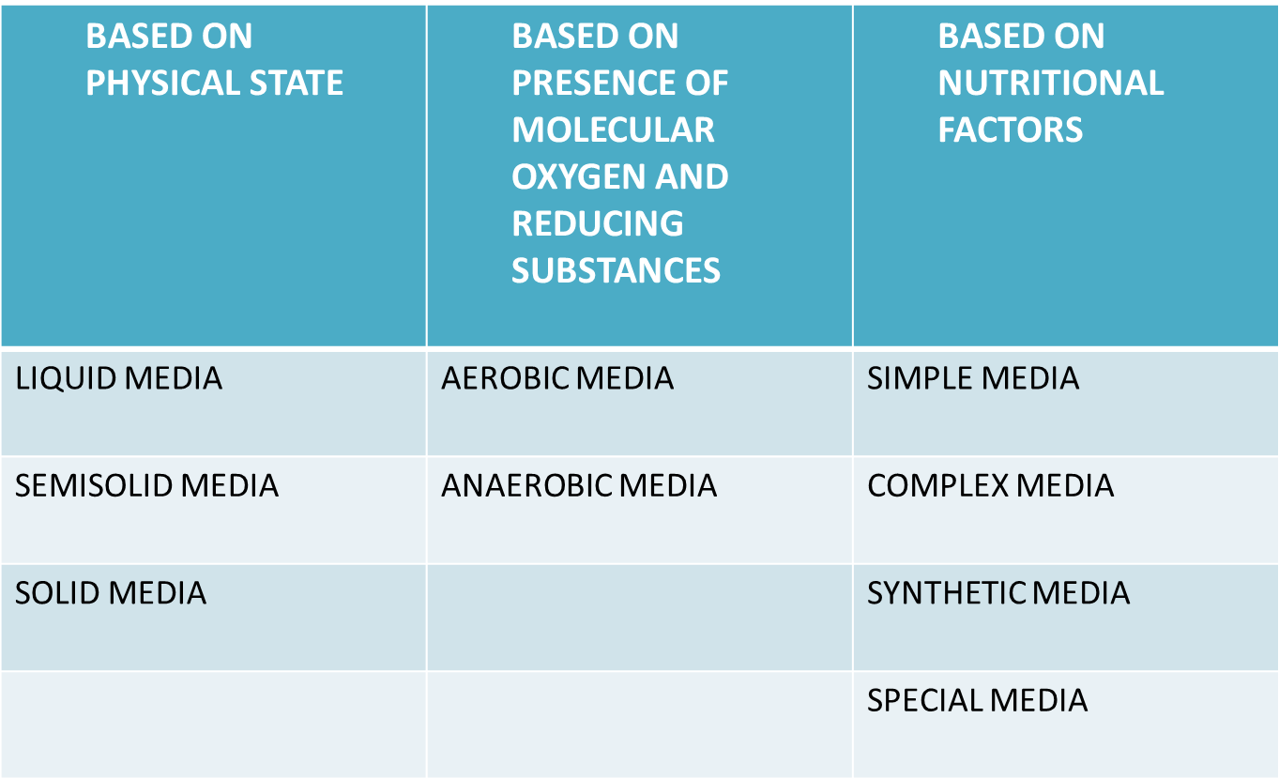

**SIMPLE MEDIA**

Simple or basal media are culture media which contain the minimum adequate nutrition for non-fastidious organisms

PEPTONE WATER

**COMPLEX MEDIA**

Complex media have added ingredients for bringing out certain properties for bringing out certain properties or providing special nutrients required for growth of the bacterium in question.

**SYNTHETIC MEDIA**

SEMIDEFINED MEDIA

SPECIAL MEDIUM

**ENRICHED MEDIA**

When basal medium is added with some nutrients such as blood, serum or egg is called enriched media.

They are used to grow bacteria which are more exacting in their nutritional needs.

**BLOOD AGAR**

TYPE : Enriched media.

APPEARANCE : Red color.

**COMPOSITION :**

Sterile Nutrient agar + blood

**USES** :

Routine culture

Widely used in medical bacteriology

It is also an indicator medium showing the haemolytic properties of bacteria such as Streptococcus pyogenes.

**CHOCOLATE AGAR**

Also called Heated blood agar.

TYPE : Enriched media.

APPEARANCE : Chocolate brown color.

**USES**

CULTURE OF Neisseria

CULTURE OF Haemophilus influenzae

CULTURE OF Pneumococcus

**SELECTIVE MEDIA**

It is a medium in which certain substances are present which inhibit all other bacteria except the desired bacteria.

Example:- TCBS

-It is selective medium for Vibrio cholera