Lec -1-
Classification of Bacteria
Bacteria are Prokaryotes – No nucleus or organelles bound in membranes.
DNA is a single circular chromosome
Cell Walls of peptidoglycan

Divide by binary fission
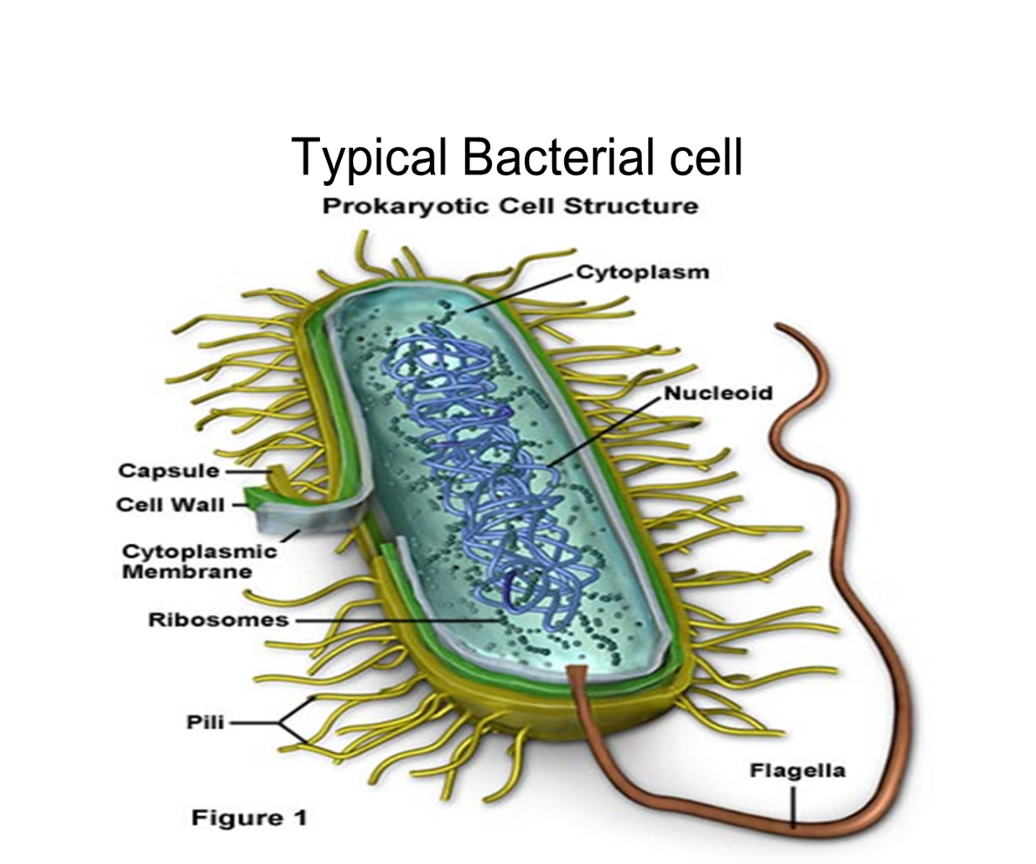

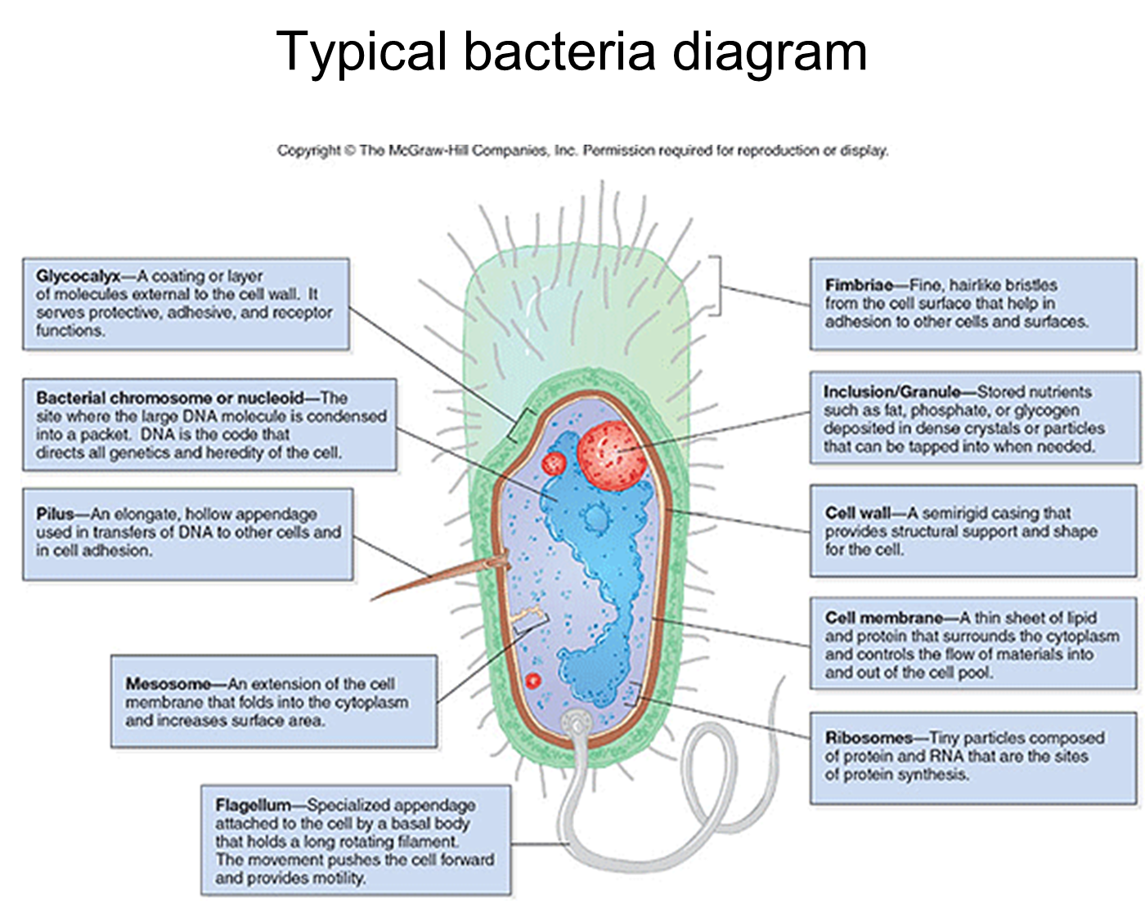

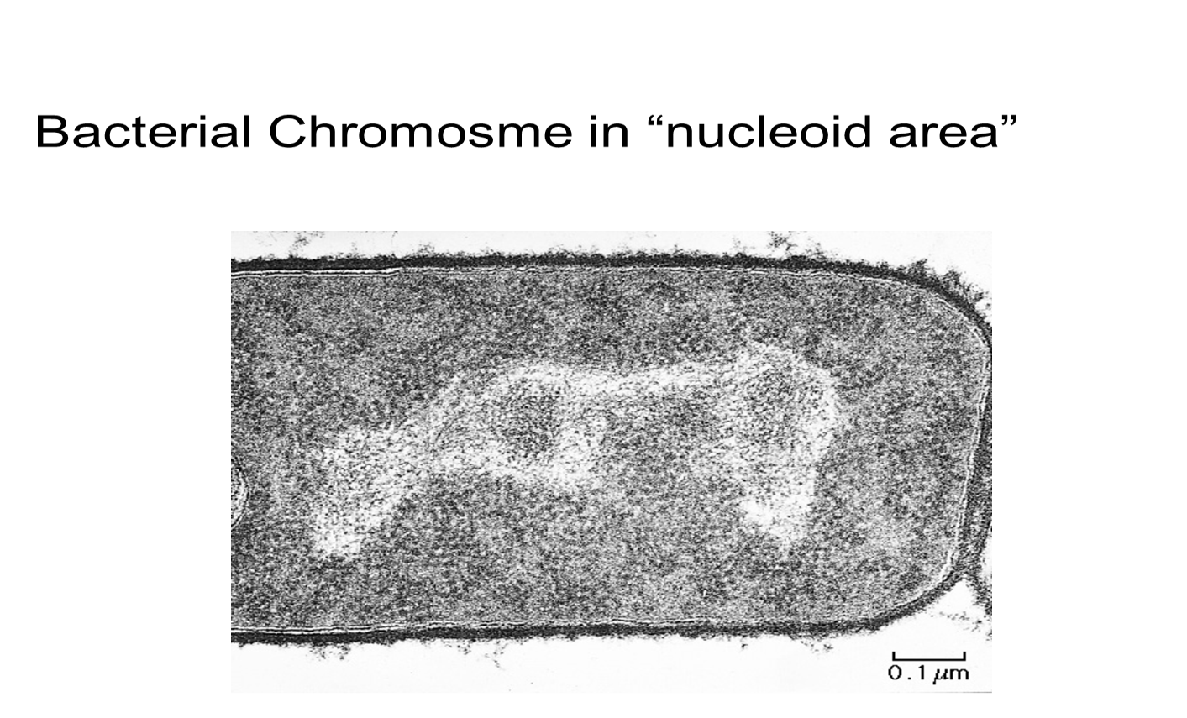
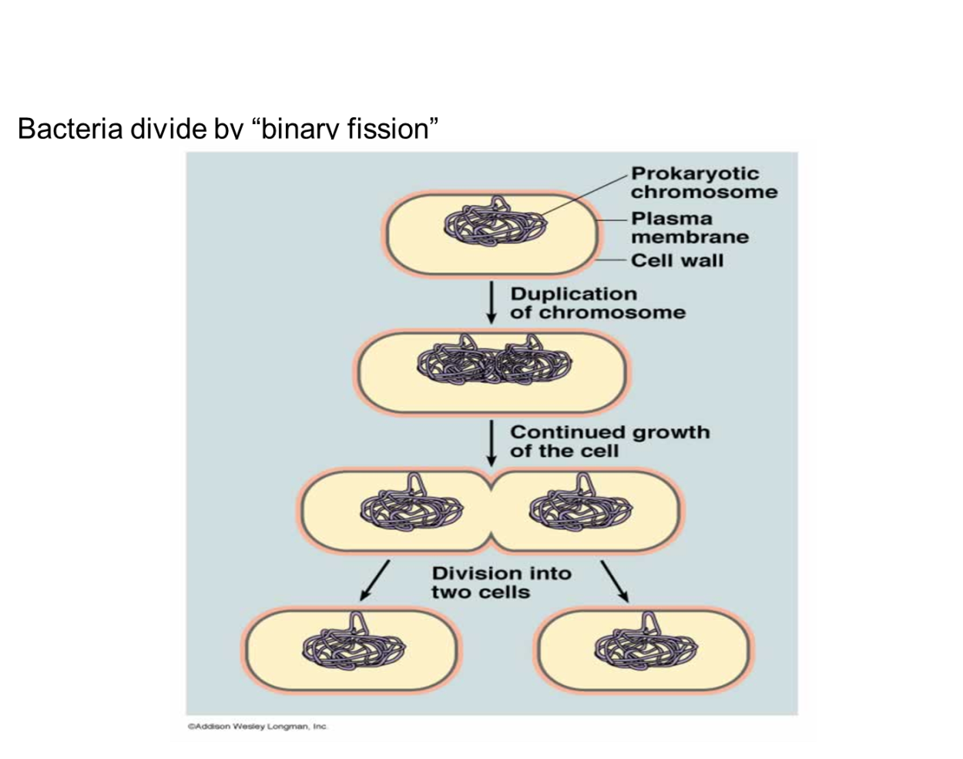

Bacterial appendages: Pilli (fimbriae) and Flagella
Pilli are short, hair-like, protein: function “adherence”

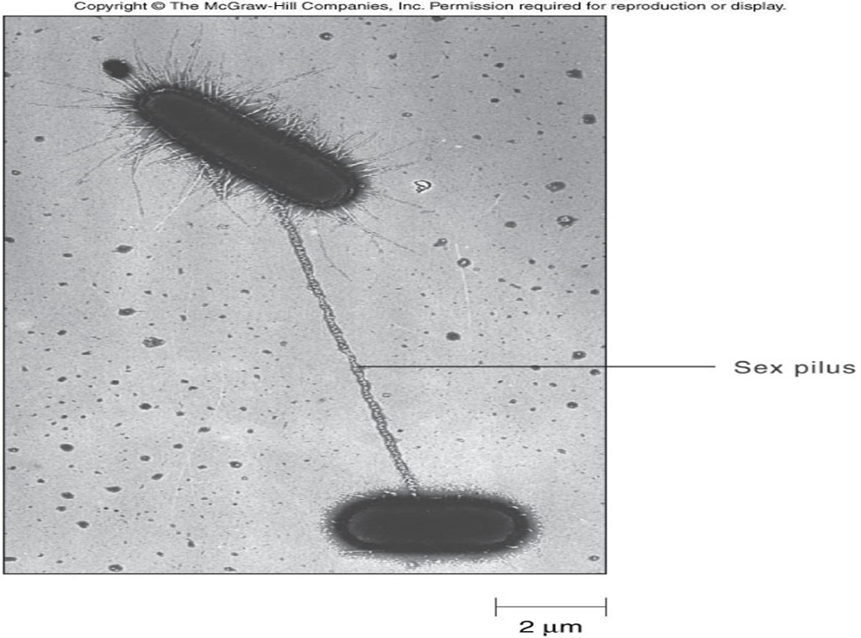

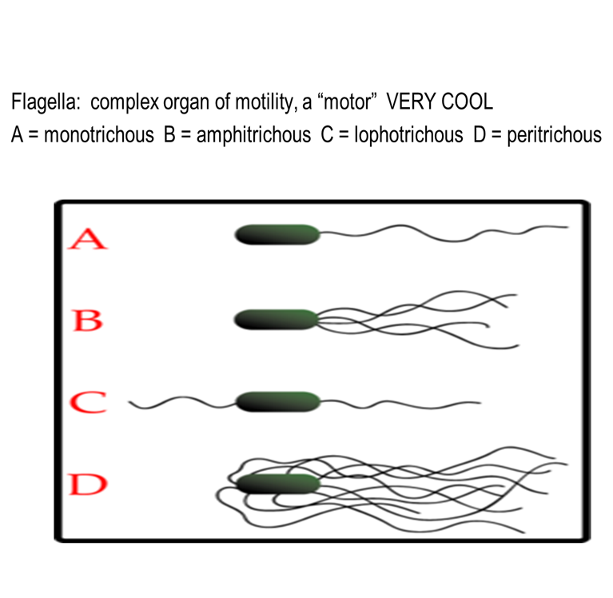
Bacterial “Envelope” – Structures on the outside of bacteria:
Glycocalyx – sugar coat, if tightly bound = capsule
Protects and prevents from drying, also protects from phagocytes

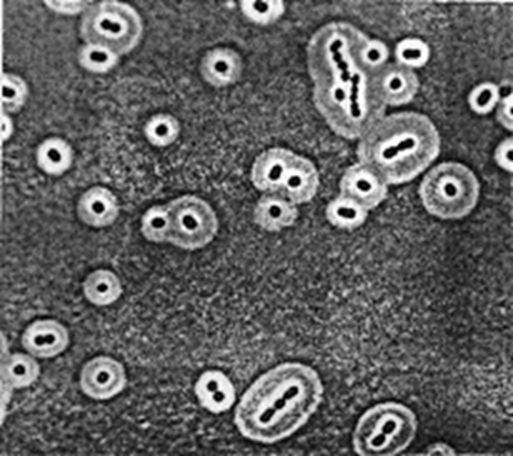

Outer membrane (outside of cell wall) found in Gram (-) bacteria

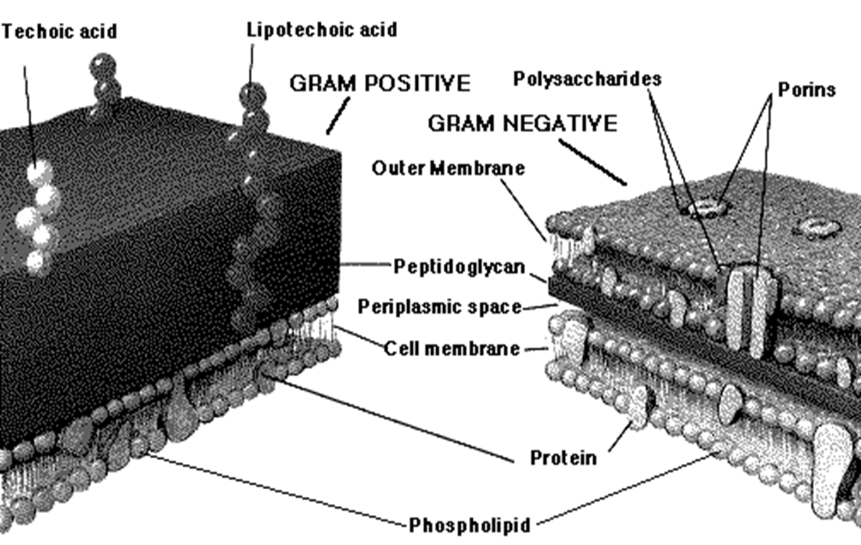

Outer membrane (outside of cell wall) found in Gram (-) bacteria ,Gram – bacteria have LPS (lipopolysaccharide), lipoprotein, and phospholipids
These can cause some of the symptoms of Gram – bacterial infections (fever, shock, diarrhea)
Bacterial Cell Wall – macromolecule, polysaccharide, repeating sugars (Peptidoglycan)
prevents rupture, protects cell, gives it its distinct shape , Certain antibiotics work by inhibiting cell wall synthesis (penicillins).

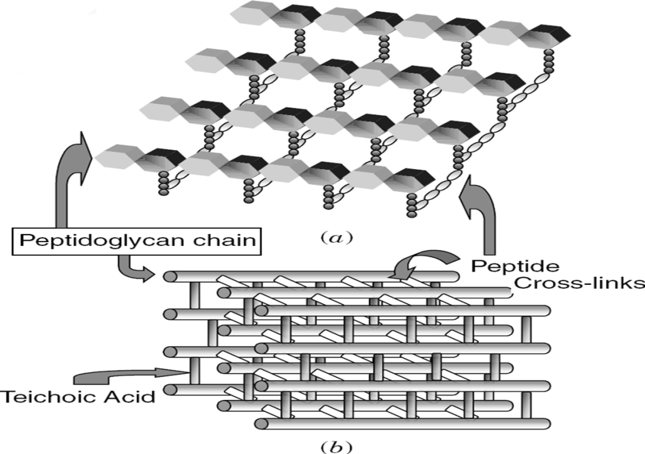

Gram + and Gram – bacteria have differences in Cell Wall and outer envelope .
Grams stain = a differential stain procedure, different results, + and (-)

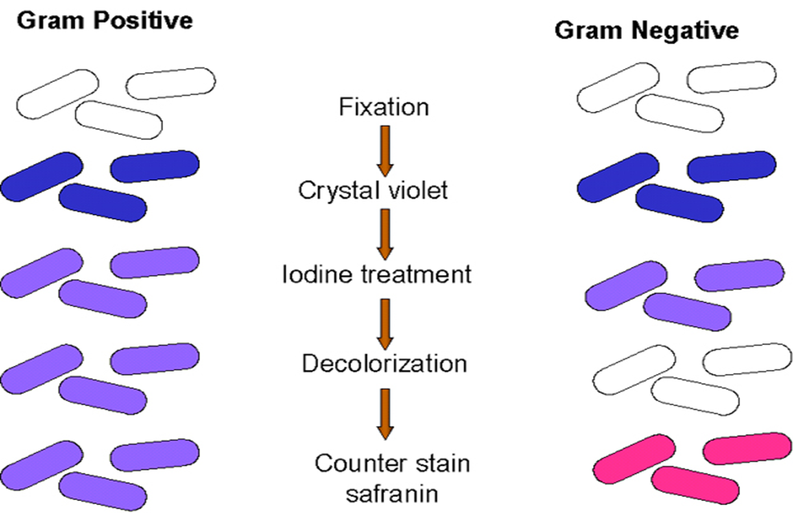

Bacterial cell “shapes”
A=bacillus or pl. bacilli
B= round, coccus, cocci pl., in chains “Streptococcus)
C. Staphylococcus – clusters D= diplococcus E=Spirillum, spirilla F= vibrio,more comma shaped

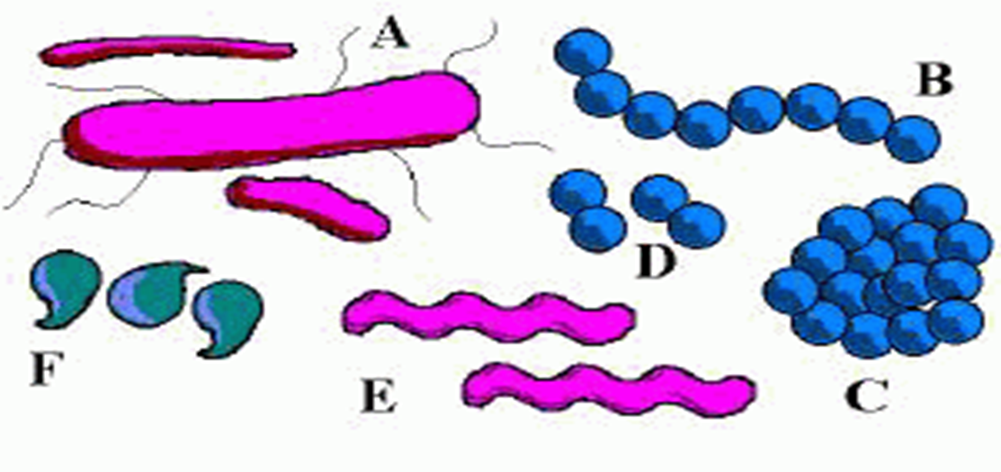

Cell shape is determined by the genetic character of the organism. Its genes code for the synthesis of the CW material and the cell division mechanism that results in a “round” or “rod” or “spiral” shape
One of the criteria used in ID of bacteria
Bacterial cell membrane: regulates what moves in and out of the cytoplasm
Diffusion –concentration gradients > high to low
Osmosis – diffusion of water across a semipermeable membrane

Passive transport
Active transport
Engulfment (phagocytosis, pinocytosis)
Inside the bacterial cytoplasm
Plasmid – Extrachromosomal DNA, not part of “genome”, different genes
Can transfer in a process – conjugation across sex pilus, change the genetic character of the recipient
Tool of “genetic”engineer
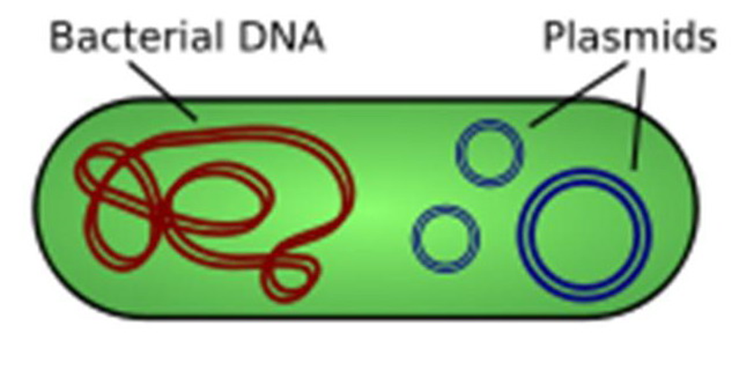

Ribosomes: structure made of RNA, site of protein synthesis
Some antibiotics work by messing with the “ribosome”
Slightly smaller than our eukaryote ribosome, so antibiotic can work on bacteria but not affect us.

