**4. Graphs.**

If (f) is a function with domain (D), its graph consists of points in Cartesian plane whose coordinate are the input – output pairs for (f).

**Example 1: Graph the function y=x2**

**Solution//**

**1. Domain function =real number (R)**

|  |  |
| --- | --- |
| **x** | **y= (x2 )** |
| **0** | **0** |
| **1** | **1** |
| **2** | **4** |
| **-1** | **1** |
| **-2** | **4** |

**2. with x-axis →y=0→x2=0→x=0→ (0,0)**

**With y-axis →x=0→y=0→(0,0)** 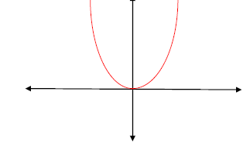

**Example 2: graph the function y= $\frac{2+3X}{4+2X}$**

**Solution//**

**1. Domain [4+2x=0 $→x=-2]$**

**Domain function=R except {$-2$}**

**2.with y- axis, x=0 $→$ y= $\frac{2+0}{4+0}$**

**y=0.5, (0,0.5)**

**with x- axis, y=0 $→$ 0= $\frac{2+3X}{4+2X}$**

$$2+3x=0→x=-2/3.(-2/3.0)$$

**3. Vertical , 4+2x=0→x=-2**

**4. Horizontal, y=3/2**

**5.**

|  |  |
| --- | --- |
| **x** | **y= $\frac{2+3X}{4+2X}$** |
| **0** | **0.5** |
| **1** | **5/6** |
| **2** | **1** |
| **-1** | **-0.5** |

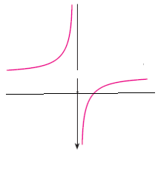

**H.W. Example: graph the function y=(x+1)2**

**5. Function; Domain and range**

Domain represents values of (x)

Range represents values of (y)

**Example1: Find the domain and range of y=x2+1**

**Solution//**

**Domain function=R or**

**y=x2+1x=**

**Range function =y $≥$ 1**

**Example 2: Find the domain and range of y= $\frac{2x}{x-1}$**

**Solution//**

**X-1=0 $→$ x=1→domain function=R except {1}**

**y= $\frac{2x}{x-1}$ →yx-y=2x**

**x= $\frac{y}{y-2}$**

**y-2=0 $→y=2$**

**Range function=R except {2}**

**Example 3: Find the domain and range of y= $\frac{1}{x+1 }$- $\frac{1}{x-1 }$**

**Solution//**

**X+1=0→x=-1**

**X-1=0 $→x=1$**

**Domain function=R except {-1,1}**

**y= $\frac{1}{x+1 }-\frac{1}{x-1 }$**

**y= $\frac{\left(x-1\right)-(x+1)}{(x+1)(x-1) }$**

**y= $\frac{-2}{(x^{2}-1) }$**

**y $x^{2}-y=-2$**

$$→x=\frac{\sqrt{-2+y}}{\sqrt{y} }$$

**y $>0 and y≥2$**

**Range function= y $>0 ∪ y≥2$**

**Example 4: Find the domain and range of y= $\sqrt{\frac{x-1}{x+2}}$**

**Solution/**

**x-1 $≥0→x≥1$**

**x+2 $≥0→x>-2$**

**Domain function={x:x}{x:x}**

**y=**

**Y2**

**Range function=R except {+ $1.-1$}**

**H.W. Example: Find the domain and range of y= $\frac{1}{\sqrt{4-X^{2}}}$**